**JUnit Testing**

**JUnit Testing Exercises:**

**Exercise 1:**

**Calculator.java**

package com.example.junitdemo;

public class Calculator {

    public int add(int a, int b) {

        return a + b;

    }

}

**CalculatorTest.java**

package com.example.junitdemo;

import static org.junit.jupiter.api.Assertions.assertEquals;

import org.junit.jupiter.api.Test;

public class CalculatorTest {

    @Test

    public void testAdd() {

        Calculator calc = new Calculator();

        int result = calc.add(2, 3);

        assertEquals(5, result);

    }

}

**Pom.xml**

<dependency>

            <groupId>junit</groupId>

            <artifactId>junit</artifactId>

            <scope>test</scope>

        </dependency>

**Output**

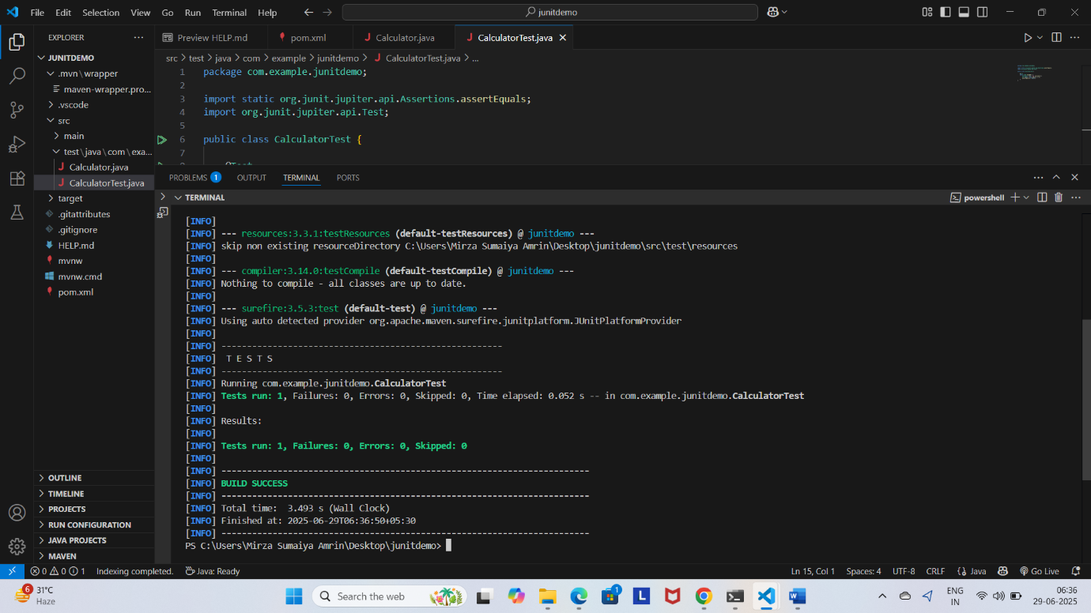

**Exercise 2:**

**Calculator.java**

package com.example.junitdemo;

public class Calculator {

public int add(int a, int b) {

return a + b;

}

public int subtract(int a, int b) {

return a - b;

}

}

**CalculatorTest.java**

// File: src/test/java/com/example/junitdemo/CalculatorTest.java

package com.example.junitdemo;

import static org.junit.jupiter.api.Assertions.assertEquals;

import org.junit.jupiter.api.Test;

public class CalculatorTest {

    @Test

    void testAdd() {

        Calculator calc = new Calculator();

        assertEquals(5, calc.add(2, 3));

    }

    @Test

    void testSubtract() {

        Calculator calc = new Calculator();

        assertEquals(1, calc.subtract(4, 3));

    }

}

**Output**

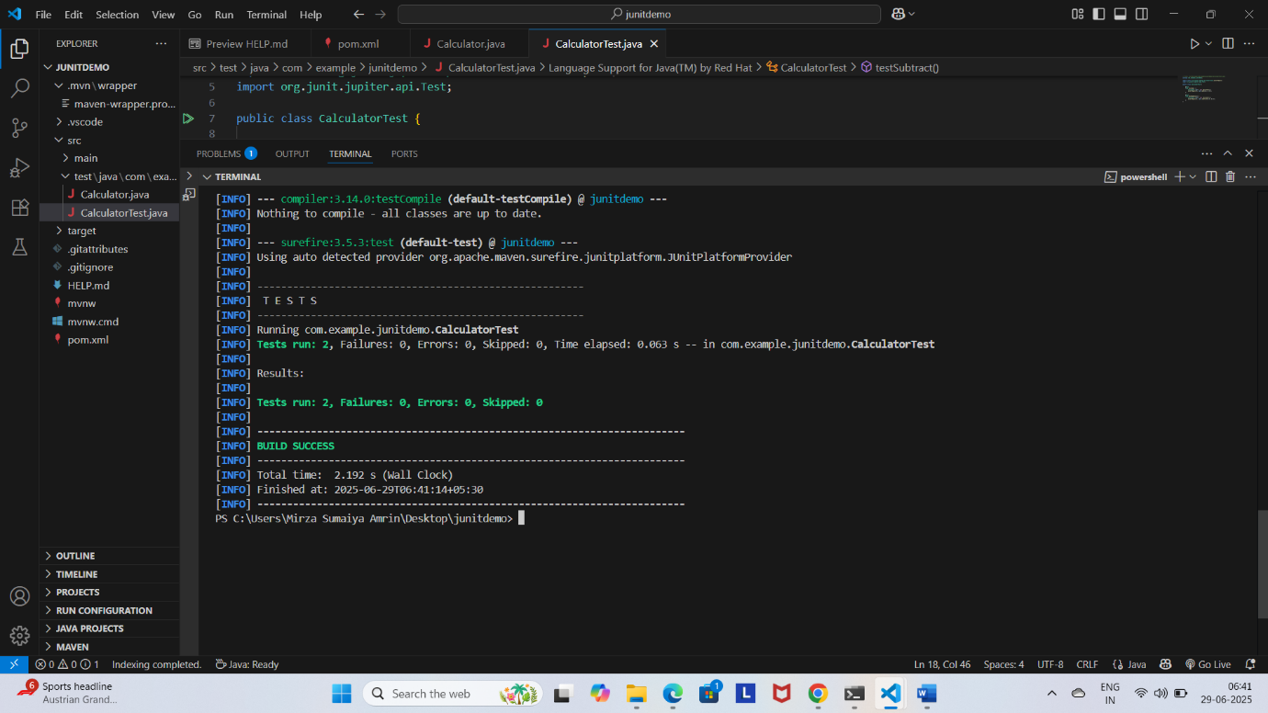

**Exercise 3:**

**AssertionsTest.java**

// File: src/test/java/com/example/junitdemo/AssertionsTest.java

package com.example.junitdemo;

import static org.junit.jupiter.api.Assertions.assertEquals;

import static org.junit.jupiter.api.Assertions.assertFalse;

import static org.junit.jupiter.api.Assertions.assertNotNull;

import static org.junit.jupiter.api.Assertions.assertNull;

import static org.junit.jupiter.api.Assertions.assertTrue;

import org.junit.jupiter.api.Test;

public class AssertionsTest {

    @Test

    void testAssertions() {

        // assertEquals

        assertEquals(5, 2 + 3);

        // assertTrue

        assertTrue(5 > 3);

        // assertFalse

        assertFalse(5 < 3);

        // assertNull

        String str = null;

        assertNull(str);

        // assertNotNull

        String name = "JUnit";

        assertNotNull(name);

    }

}

**Output:**

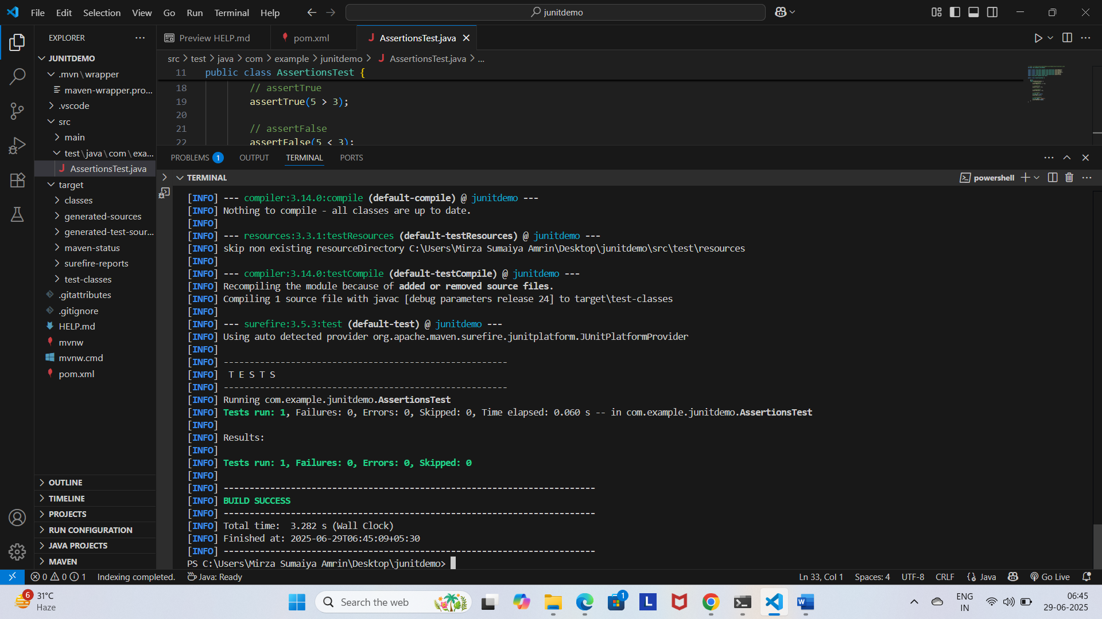

**Exercise 4:**

**Calculator.java**

// File: src/main/java/com/example/junitdemo/Calculator.java

package com.example.junitdemo;

public class Calculator {

    public int add(int a, int b) {

        return a + b;

    }

    public int subtract(int a, int b) {

        return a - b;

    }

}

**CalculatorLifecycleTest.java**

// File: src/test/java/com/example/junitdemo/CalculatorLifecycleTest.java

package com.example.junitdemo;

import org.junit.jupiter.api.AfterEach;

import static org.junit.jupiter.api.Assertions.assertEquals;

import org.junit.jupiter.api.BeforeEach;

import org.junit.jupiter.api.Test;

public class CalculatorLifecycleTest {

    private Calculator calculator;

    @BeforeEach

    void setUp() {

        // Arrange: Create Calculator instance before each test

        calculator = new Calculator();

        System.out.println("Setup complete");

    }

    @AfterEach

    void tearDown() {

        // Cleanup: This runs after each test

        calculator = null;

        System.out.println("Teardown complete");

    }

    @Test

    void testAddition() {

        // Act

        int result = calculator.add(10, 20);

        // Assert

        assertEquals(30, result);

    }

    @Test

    void testSubtraction() {

        // Act

        int result = calculator.subtract(10, 4);

        // Assert

        assertEquals(6, result);

    }

}

**Output:**

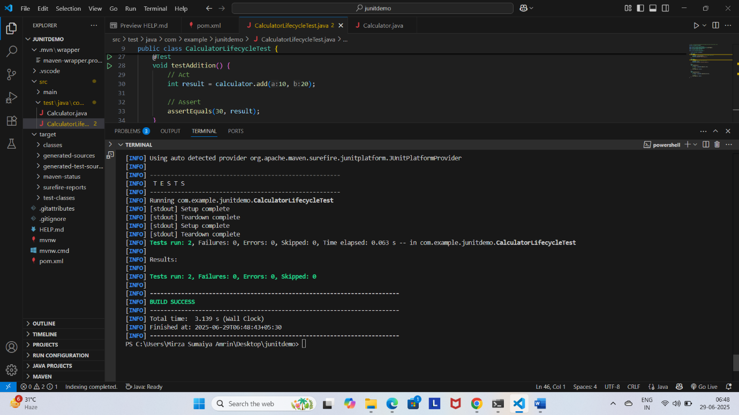

**2.**

**Exercise 1:**

**EvenChecker.java**

ckage com.example.junitdemo;

public class EvenChecker {

    public boolean isEven(int number) {

        return number % 2 == 0;

    }

}

**EvenCheckerTest.java**

package com.example.junitdemo;

import static org.junit.jupiter.api.Assertions.assertFalse;

import static org.junit.jupiter.api.Assertions.assertTrue;

import org.junit.jupiter.params.ParameterizedTest;

import org.junit.jupiter.params.provider.ValueSource;

public class EvenCheckerTest {

    private final EvenChecker checker = new EvenChecker();

    @ParameterizedTest

    @ValueSource(ints = {2, 4, 6, 8, 10})

    void testIsEven(int number) {

        assertTrue(checker.isEven(number));

    }

    @ParameterizedTest

    @ValueSource(ints = {1, 3, 5, 7, 9})

    void testIsNotEven(int number) {

        assertFalse(checker.isEven(number));

    }

}

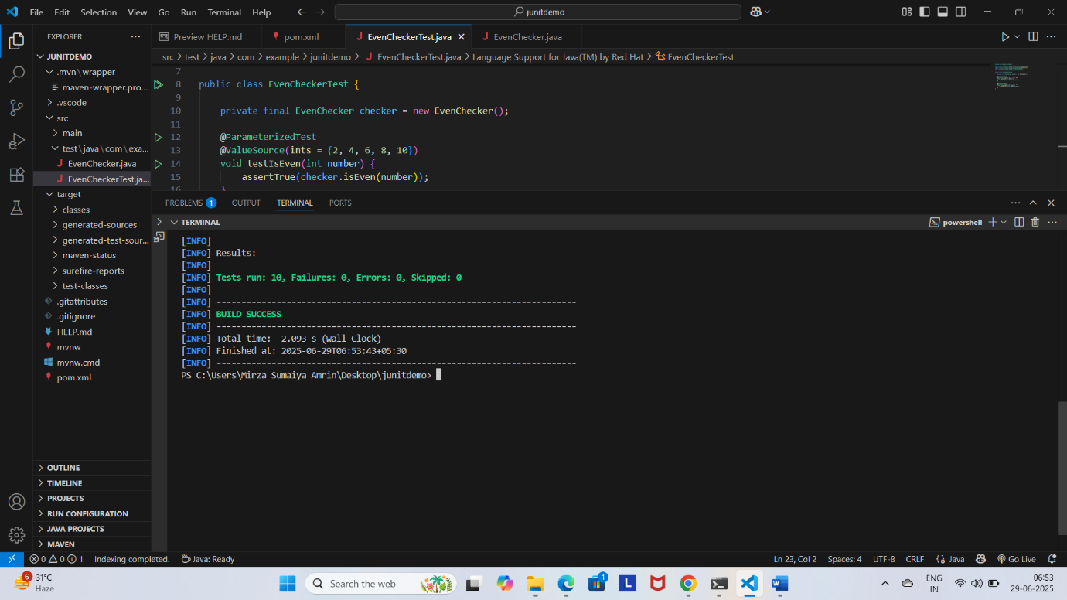**Output:**

**Exercise 2:**

**pom.xml**

<dependency>

    <groupId>org.junit.platform</groupId>

    <artifactId>junit-platform-suite</artifactId>

     <!-- Match your JUnit version -->

    <scope>test</scope>

</dependency>

    <dependency>

        <groupId>org.junit.jupiter</groupId>

        <artifactId>junit-jupiter</artifactId>

        <scope>test</scope>

    </dependency>

**Calculator.java**

// File: src/main/java/com/example/junitdemo/Calculator.java

package com.example.junitdemo;

public class Calculator {

    public int add(int a, int b) {

        return a + b;

    }

    public int subtract(int a, int b) {

        return a - b;

    }

}

**CalculatorTest.java**

// File: src/test/java/com/example/junitdemo/CalculatorTest.java

package com.example.junitdemo;

import static org.junit.jupiter.api.Assertions.assertEquals;

import org.junit.jupiter.api.Test;

public class CalculatorTest {

    @Test

    void testAdd() {

        Calculator calc = new Calculator();

        assertEquals(5, calc.add(2, 3));

    }

    @Test

    void testSubtract() {

        Calculator calc = new Calculator();

        assertEquals(1, calc.subtract(4, 3));

    }

}

**AssertionsTest.java**

// File: src/test/java/com/example/junitdemo/AssertionsTest.java

package com.example.junitdemo;

import static org.junit.jupiter.api.Assertions.assertEquals;

import static org.junit.jupiter.api.Assertions.assertFalse;

import static org.junit.jupiter.api.Assertions.assertNotNull;

import static org.junit.jupiter.api.Assertions.assertNull;

import static org.junit.jupiter.api.Assertions.assertTrue;

import org.junit.jupiter.api.Test;

public class AssertionsTest {

    @Test

    void testAssertions() {

        // assertEquals

        assertEquals(5, 2 + 3);

        // assertTrue

        assertTrue(5 > 3);

        // assertFalse

        assertFalse(5 < 3);

        // assertNull

        String str = null;

        assertNull(str);

        // assertNotNull

        String name = "JUnit";

        assertNotNull(name);

    }

}

**EvenChecker.java**

package com.example.junitdemo;

public class EvenChecker {

    public boolean isEven(int number) {

        return number % 2 == 0;

    }

}

**EvenCheckerTest.java**

package com.example.junitdemo;

import static org.junit.jupiter.api.Assertions.assertFalse;

import static org.junit.jupiter.api.Assertions.assertTrue;

import org.junit.jupiter.params.ParameterizedTest;

import org.junit.jupiter.params.provider.ValueSource;

public class EvenCheckerTest {

    private final EvenChecker checker = new EvenChecker();

    @ParameterizedTest

    @ValueSource(ints = {2, 4, 6, 8, 10})

    void testIsEven(int number) {

        assertTrue(checker.isEven(number));

    }

    @ParameterizedTest

    @ValueSource(ints = {1, 3, 5, 7, 9})

    void testIsNotEven(int number) {

        assertFalse(checker.isEven(number));

    }

}

**AllTests.java**

package com.example.junitdemo;

import org.junit.platform.suite.api.SelectClasses;

import org.junit.platform.suite.api.Suite;

@Suite

@SelectClasses({

        CalculatorTest.class,

        AssertionsTest.class,

        EvenCheckerTest.class

})

public class AllTests {

    // No methods needed – this class runs all included tests

}

**Output:**

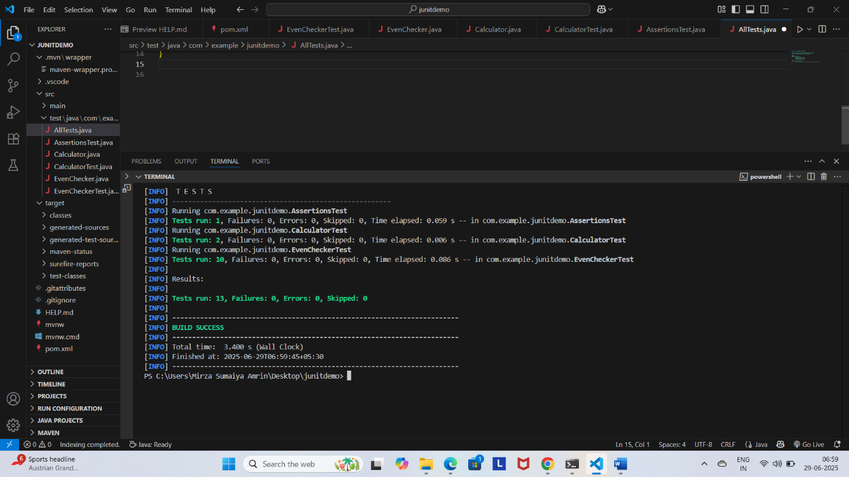

**Exercise 3:**

**OrderedTests.java**

package com.example.junitdemo;

import static org.junit.jupiter.api.Assertions.assertTrue;

import org.junit.jupiter.api.MethodOrderer;

import org.junit.jupiter.api.Order;

import org.junit.jupiter.api.Test;

import org.junit.jupiter.api.TestMethodOrder;

@TestMethodOrder(MethodOrderer.OrderAnnotation.class)

public class OrderedTests {

    @Test

    @Order(1)

    void testFirst() {

        System.out.println("First test");

        assertTrue(true);

    }

    @Test

    @Order(2)

    void testSecond() {

        System.out.println("Second test");

        assertTrue(true);

    }

    @Test

    @Order(3)

    void testThird() {

        System.out.println("Third test");

        assertTrue(true);

    }

}

**Output:**

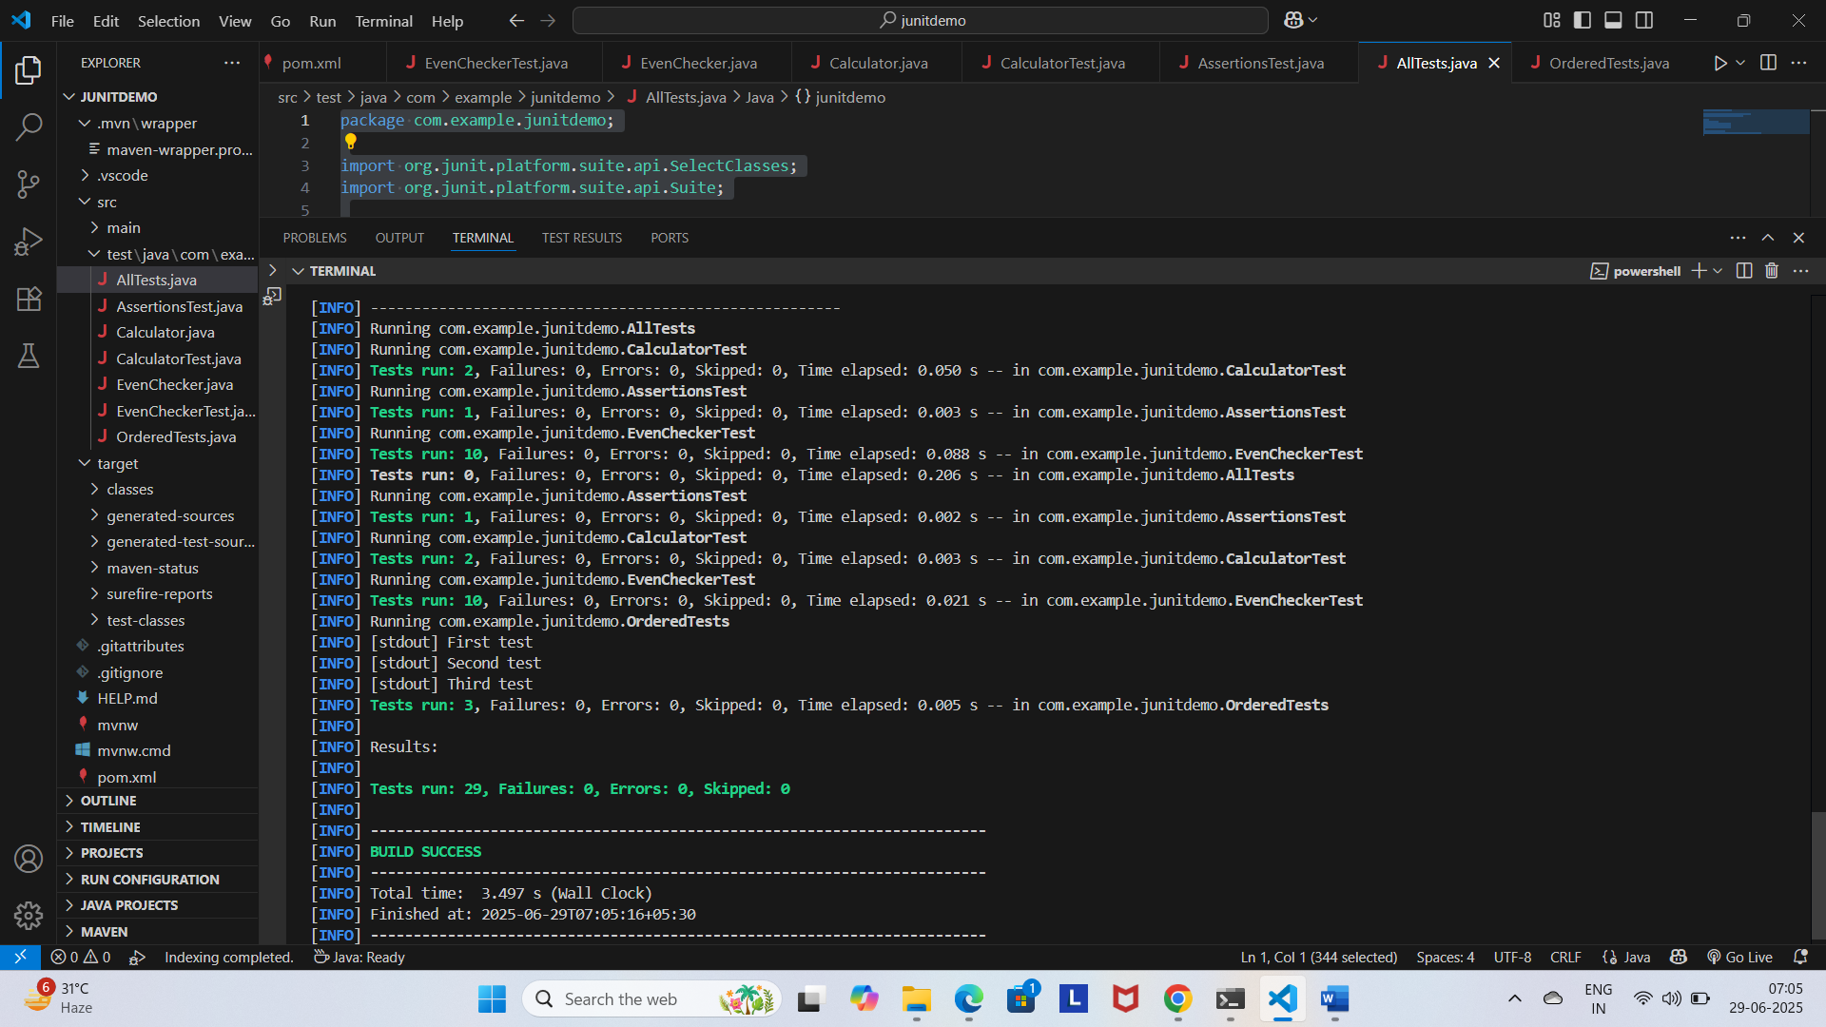

**Exercise 4:**

**ExceptionThrower.java**

package com.example.junitdemo;

public class ExceptionThrower {

    public void throwException() {

        throw new IllegalArgumentException("Invalid argument!");

    }

}

**ExceptionThrowerTest.java**

package com.example.junitdemo;

import org.junit.jupiter.api.Test;

import static org.junit.jupiter.api.Assertions.*;

public class ExceptionThrowerTest {

    @Test

    void testExceptionIsThrown() {

        ExceptionThrower thrower = new ExceptionThrower();

        assertThrows(IllegalArgumentException.class, thrower::throwException);

    }

}

**Output:**

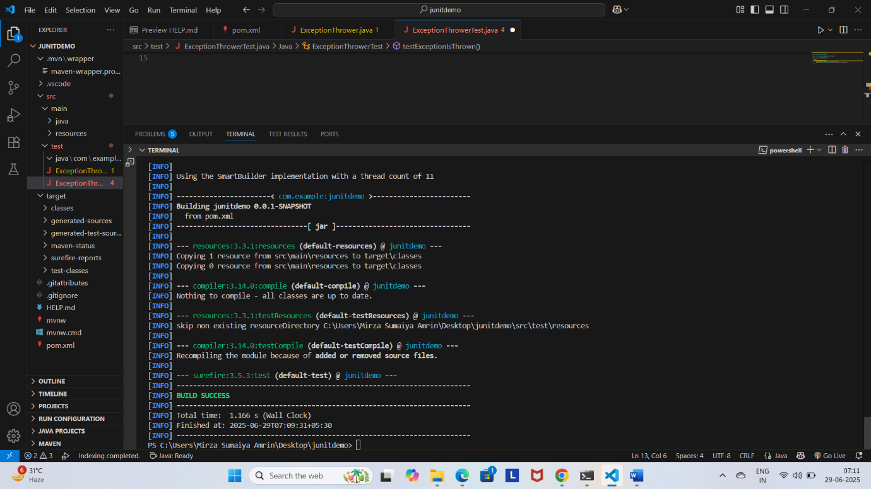

**Exercise 5:**

**PerformanceTester.java**

package com.example.junitdemo;

public class PerformanceTester {

    public void performTask() throws InterruptedException {

        // Simulate some work

        Thread.sleep(500); // 500 ms

    }

}

**PerformanceTesterTest.java**

package com.example.junitdemo;

import org.junit.jupiter.api.Test;

import static org.junit.jupiter.api.Assertions.assertTimeout;

import java.time.Duration;

public class PerformanceTesterTest {

    @Test

    void testPerformTaskWithinTime() {

        PerformanceTester tester = new PerformanceTester();

        assertTimeout(Duration.ofSeconds(1), () -> tester.performTask());

    }

}

**Output:**

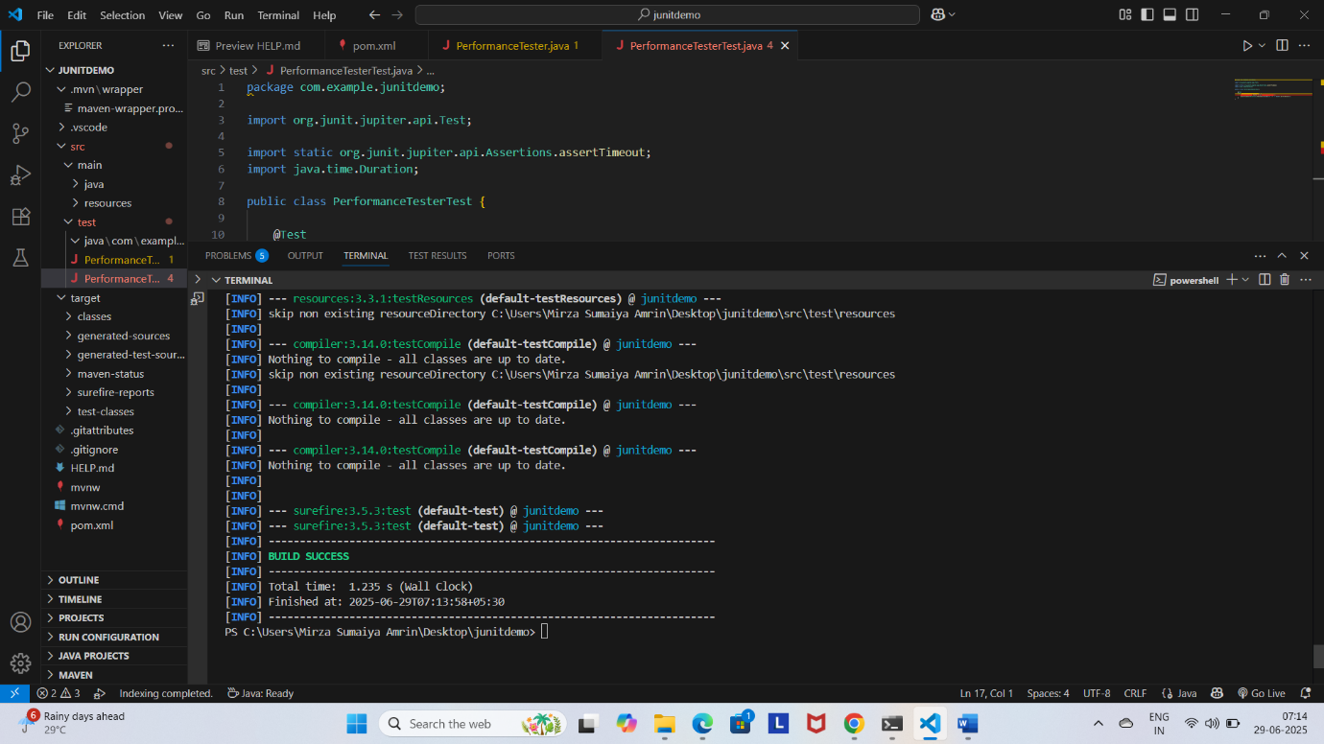

**3.**

**Exercise 1:**

**MyServiceTest.java**

import static org.mockito.Mockito.*;

import static org.junit.jupiter.api.Assertions.*;

import org.junit.jupiter.api.Test;

class ExternalApi {

    public String getData() {

        return "Real Data";

    }

}

class MyService {

    private final ExternalApi api;

    public MyService(ExternalApi api) {

        this.api = api;

    }

    public String fetchData() {

        return api.getData();

    }

}

public class MyServiceTest {

    @Test

    public void testExternalApi() {

        ExternalApi mockApi = mock(ExternalApi.class);

        when(mockApi.getData()).thenReturn("Mock Data");

        MyService service = new MyService(mockApi);

        String result = service.fetchData();

  assertEquals("Mock Data", result);

    }

}

**Output:**

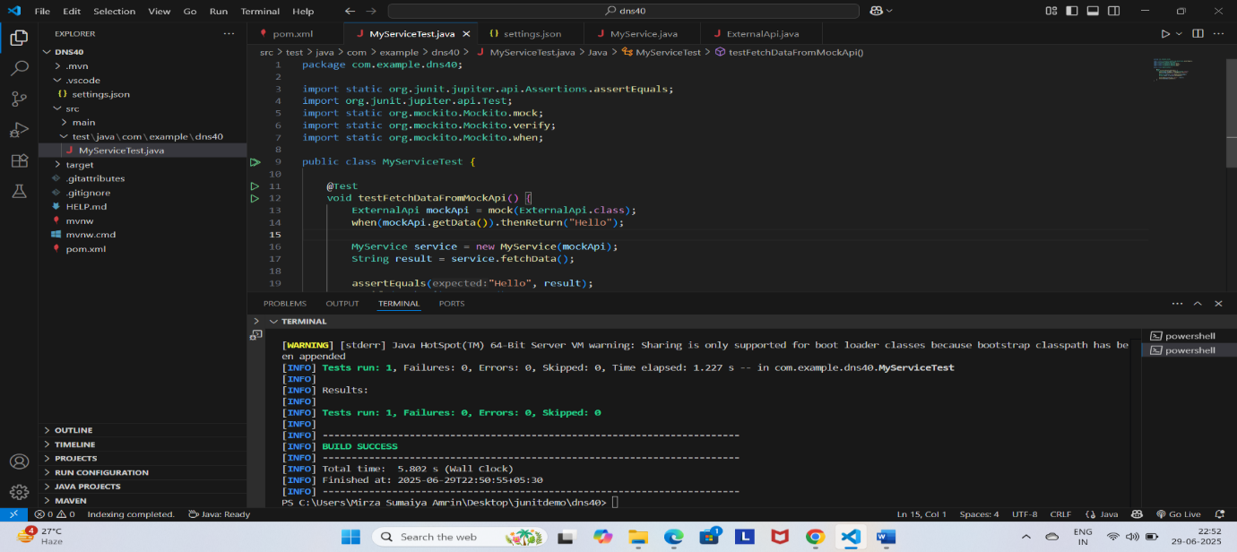

**Exercise 2:**

**MyService.java**

package com.example.dns40;

public class MyService {

    private final ExternalApi externalApi;

    public MyService(ExternalApi externalApi) {

        this.externalApi = externalApi;

    }

    public String fetchData() {

        return externalApi.getData();

    }

}

**ExternalApi.java**

package com.example.dns40;

public interface ExternalApi {

    String getData();

}

**MyServiceTest.java**

package com.example.dns40;

import org.junit.jupiter.api.Test;

import static org.mockito.Mockito.mock;

import static org.mockito.Mockito.verify;

public class MyServiceTest {

    @Test

    public void testVerifyInteraction() {

        // Step 1: Create a mock object

        ExternalApi mockApi = mock(ExternalApi.class);

        // Step 2: Pass it to the service and call the method

        MyService service = new MyService(mockApi);

        service.fetchData();

        // Step 3: Verify that getData() was called once

        verify(mockApi).getData();

    }

}

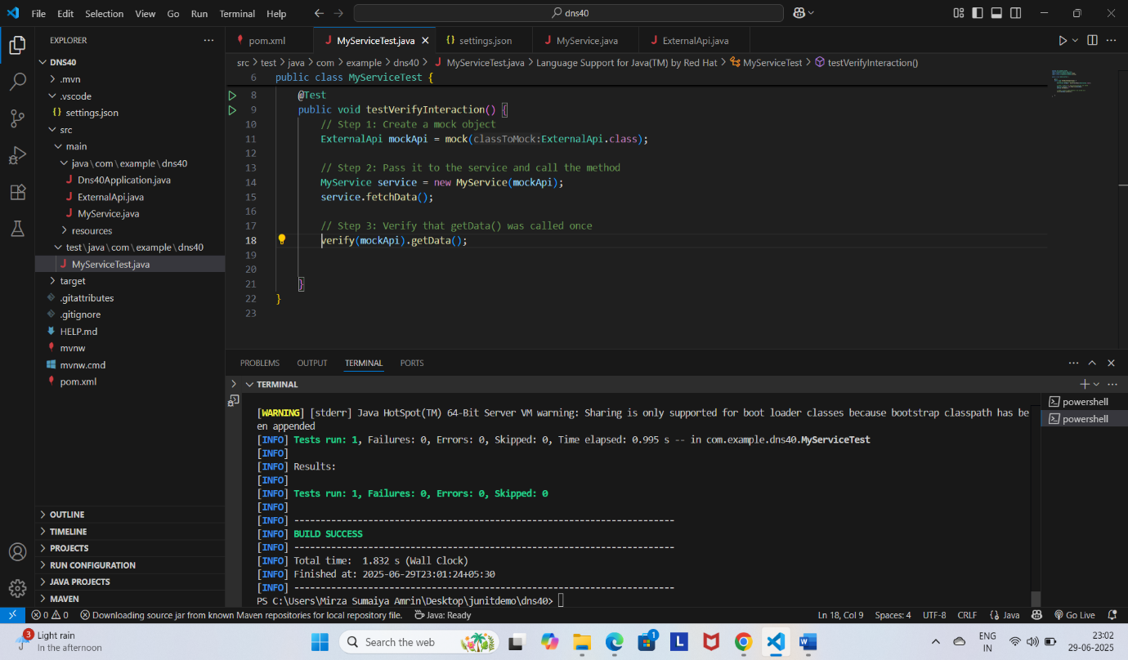**Output:**

**Exercise 3:**

**MyService.java**

package com.example.dns40;

public class MyService {

    private final ExternalApi externalApi;

    public MyService(ExternalApi externalApi) {

        this.externalApi = externalApi;

    }

    public void notifyUser(String userId) {

        externalApi.sendMessage(userId, "Welcome!");

    }

}

**ExternalApi.java**

package com.example.dns40;

public interface ExternalApi {

    void sendMessage(String userId, String message);

}

**MyServiceTest.java**

package com.example.dns40;

import org.junit.jupiter.api.Test;

import static org.mockito.ArgumentMatchers.eq;

import static org.mockito.Mockito.mock;

import static org.mockito.Mockito.verify;

public class MyServiceTest {

    @Test

    public void testArgumentMatching() {

        // Step 1: Create mock

        ExternalApi mockApi = mock(ExternalApi.class);

        // Step 2: Inject and call method

        MyService service = new MyService(mockApi);

        service.notifyUser("user123");

        // Step 3: Verify interaction with argument matchers

        verify(mockApi).sendMessage(eq("user123"), eq("Welcome!"));

    }

}

**Output:**

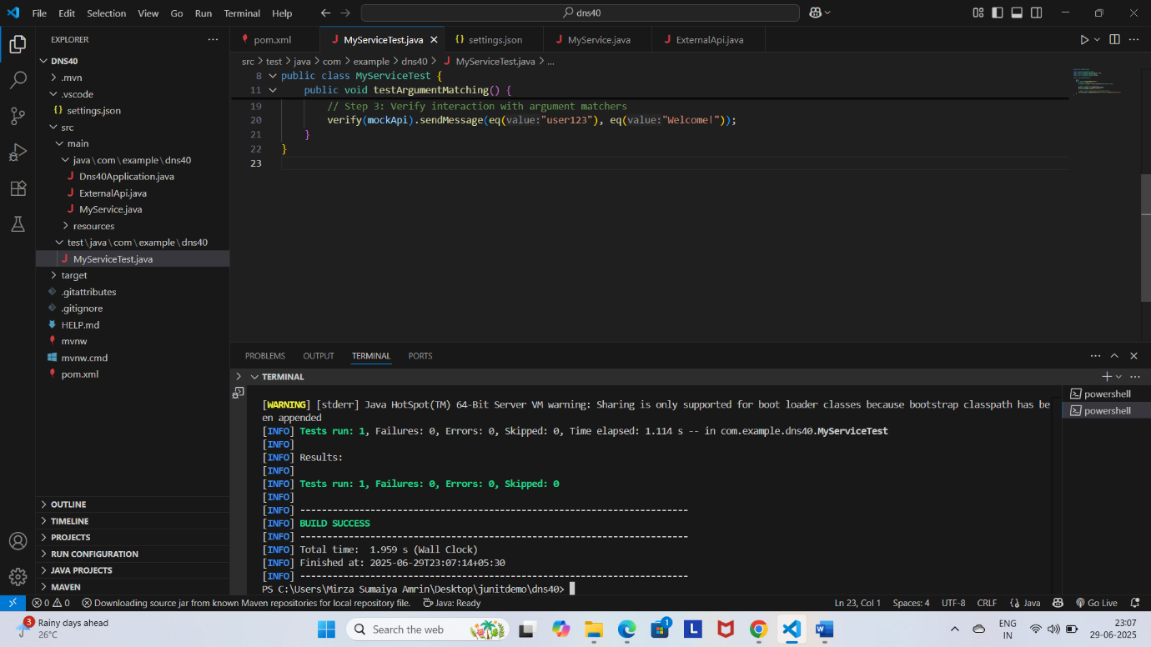

**Exercise 4:**

**MyService.java**

package com.example.dns40;

public class MyService {

    private final ExternalApi externalApi;

    public MyService(ExternalApi externalApi) {

        this.externalApi = externalApi;

    }

    public void performAction() {

        // Performs some logic and logs an event

        externalApi.logEvent("Action performed");

    }

}

**ExternalApi.java**

package com.example.dns40;

public interface ExternalApi {

    void logEvent(String message);

}

**MyServiceTest.java**

package com.example.dns40;

import org.junit.jupiter.api.Test;

import static org.mockito.Mockito.doNothing;

import static org.mockito.Mockito.mock;

import static org.mockito.Mockito.verify;

public class MyServiceTest {

    @Test

    public void testVoidMethodInteraction() {

        // Step 1: Create mock object

        ExternalApi mockApi = mock(ExternalApi.class);

        // Step 2: Optionally stub the void method (not needed unless you want to throw/doNothing)

        doNothing().when(mockApi).logEvent("Action performed");

        // Step 3: Call the method and verify interaction

        MyService service = new MyService(mockApi);

        service.performAction();

        // Verify the void method was called

        verify(mockApi).logEvent("Action performed");

    }

}

**Output:**

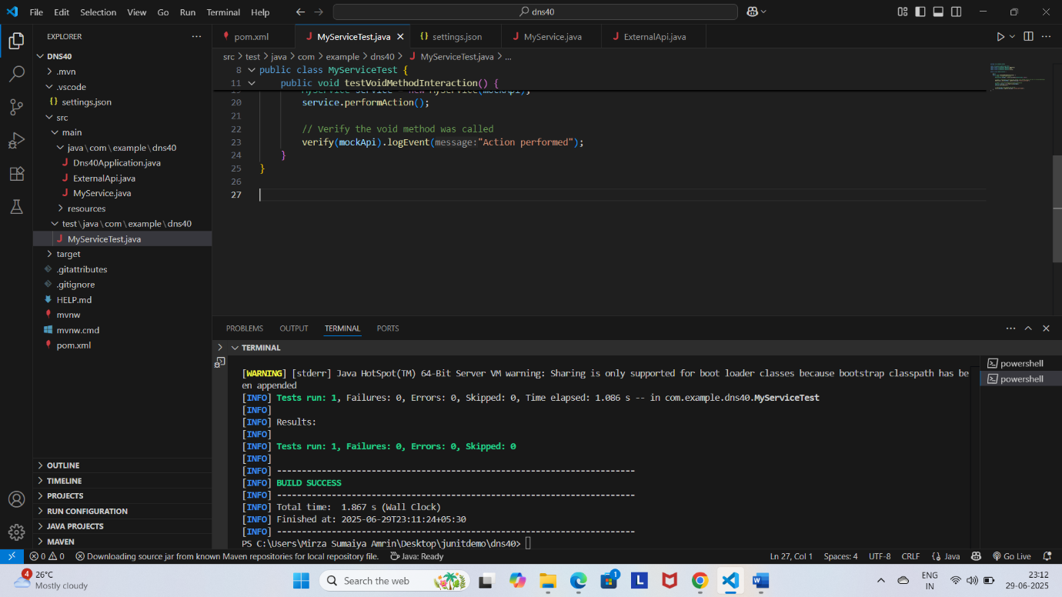

**Exercise 5:**

**MyService.java**

package com.example.dns40;

public class MyService {

    private final ExternalApi api;

    public MyService(ExternalApi api) {

        this.api = api;

    }

    public String checkMultipleStatuses() {

        return api.getStatus() + ", " + api.getStatus();

    }

}

**ExternalApi.java**

package com.example.dns40;

public interface ExternalApi {

    String getStatus();

}

**MyServiceTest.java**

package com.example.dns40;

import static org.junit.jupiter.api.Assertions.assertEquals;

import org.junit.jupiter.api.Test;

import static org.mockito.Mockito.mock;

import static org.mockito.Mockito.when;

public class MyServiceTest {

   @Test

public void testMultipleReturnValues() {

    ExternalApi mockApi = mock(ExternalApi.class);

    // Stub with multiple return values

    when(mockApi.getStatus()).thenReturn("Loading", "Complete");

    MyService service = new MyService(mockApi);

    String result = service.checkMultipleStatuses();

    assertEquals("Loading, Complete", result);

}

}

**Output:**

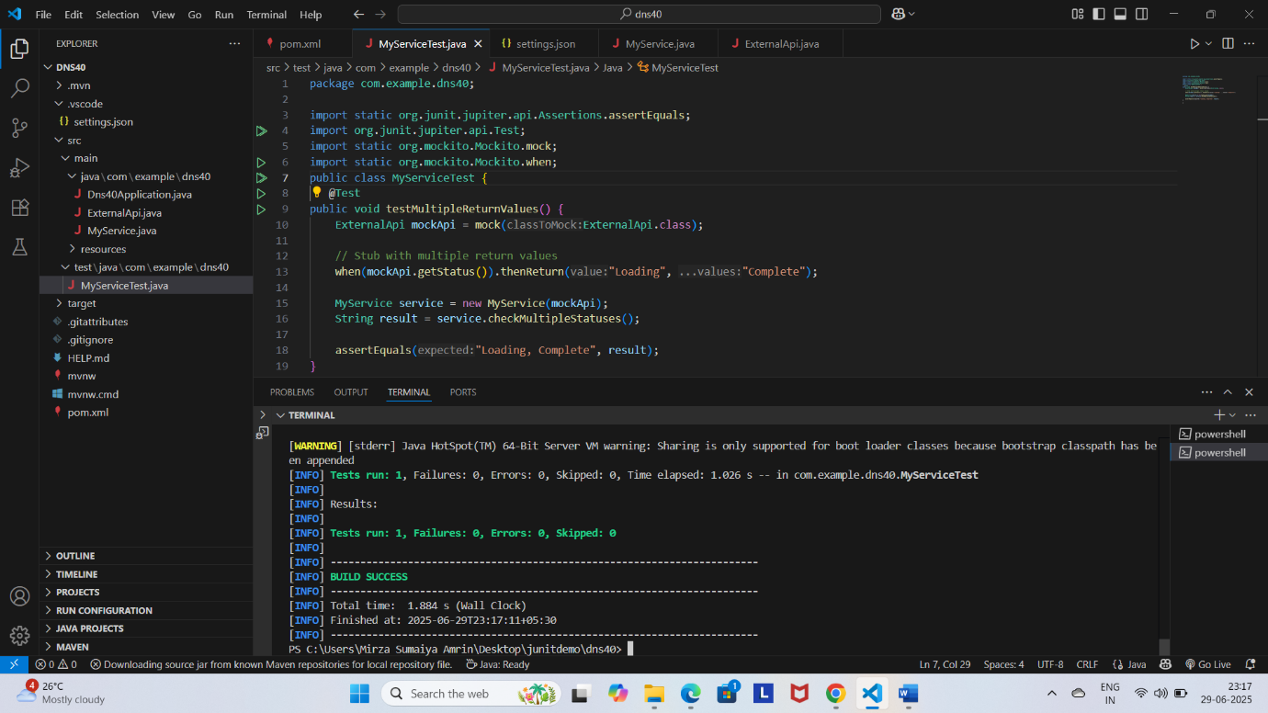

**Exercise 6:**

**MyService.java**

package com.example.dns40;

public class MyService {

    private final ExternalApi api;

    public MyService(ExternalApi api) {

        this.api = api;

    }

    public void fullProcess() {

        api.connect();

        api.fetch();

        api.disconnect();

    }

}

**MyServiceTest.java**

package com.example.dns40;

import org.junit.jupiter.api.Test;

import org.mockito.InOrder;

import static org.mockito.Mockito.inOrder;

import static org.mockito.Mockito.mock;

public class MyServiceTest {

 @Test

public void testInteractionOrder() {

    ExternalApi mockApi = mock(ExternalApi.class);

    MyService service = new MyService(mockApi);

    service.fullProcess();

    // Verify order

    InOrder inOrder = inOrder(mockApi);

    inOrder.verify(mockApi).connect();

    inOrder.verify(mockApi).fetch();

    inOrder.verify(mockApi).disconnect();

}

}

**ExternalApi.java**

package com.example.dns40;

public interface ExternalApi {

    void connect();

    void fetch();

    void disconnect();

}

**Output:**

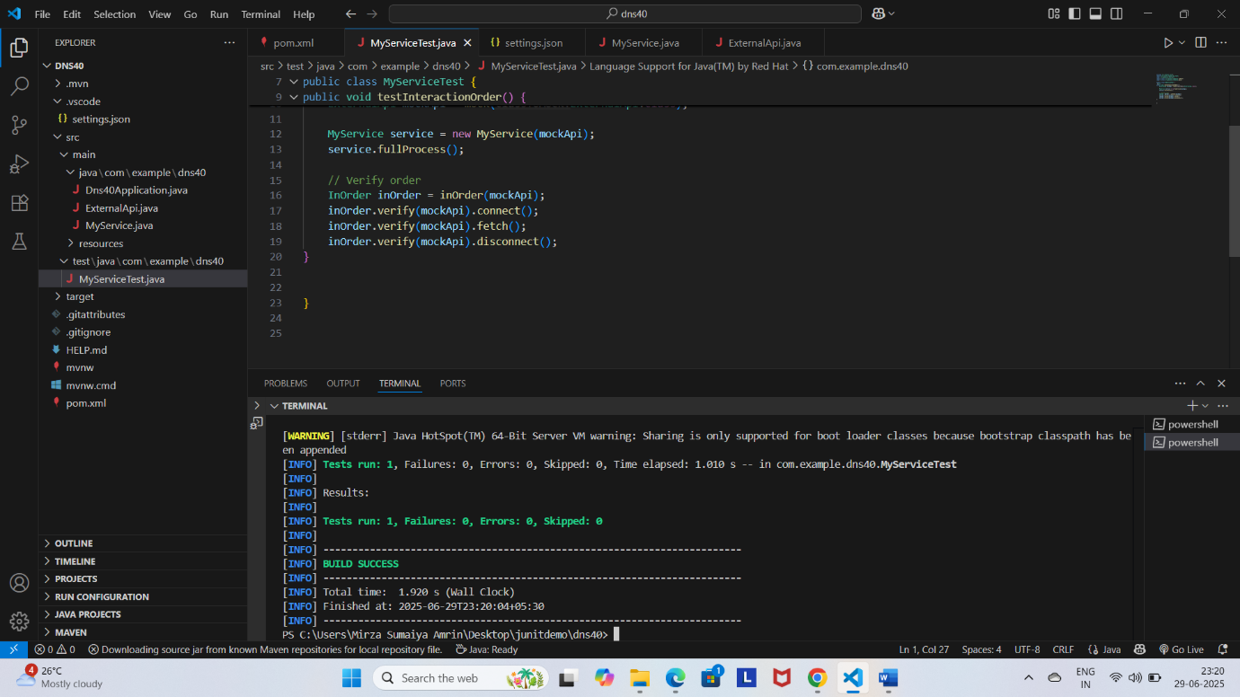

**Exercise 7:**

**MyService.java**

package com.example.dns40;

public class MyService {

    private final ExternalApi api;

    public MyService(ExternalApi api) {

        this.api = api;

    }

    public void performAndLog() {

        api.logEvent("Start");

    }

}

**ExternalApi.java**

package com.example.dns40;

public interface ExternalApi {

    void logEvent(String msg);

}

**MyServiceTest.java**

package com.example.dns40;

import org.junit.jupiter.api.Test;

import static org.mockito.Mockito.*;

import static org.junit.jupiter.api.Assertions.*;

public class MyServiceTest {

    @Test

    public void testVoidMethodThrowsException() {

        ExternalApi mockApi = mock(ExternalApi.class);

        // Simulate exception thrown on void method

        doThrow(new RuntimeException("Log failed")).when(mockApi).logEvent("Start");

        MyService service = new MyService(mockApi);

        // Check that exception is thrown

        assertThrows(RuntimeException.class, () -> {

            service.performAndLog();

        });

        // Verify interaction

        verify(mockApi).logEvent("Start");

    }

}

**Output:**

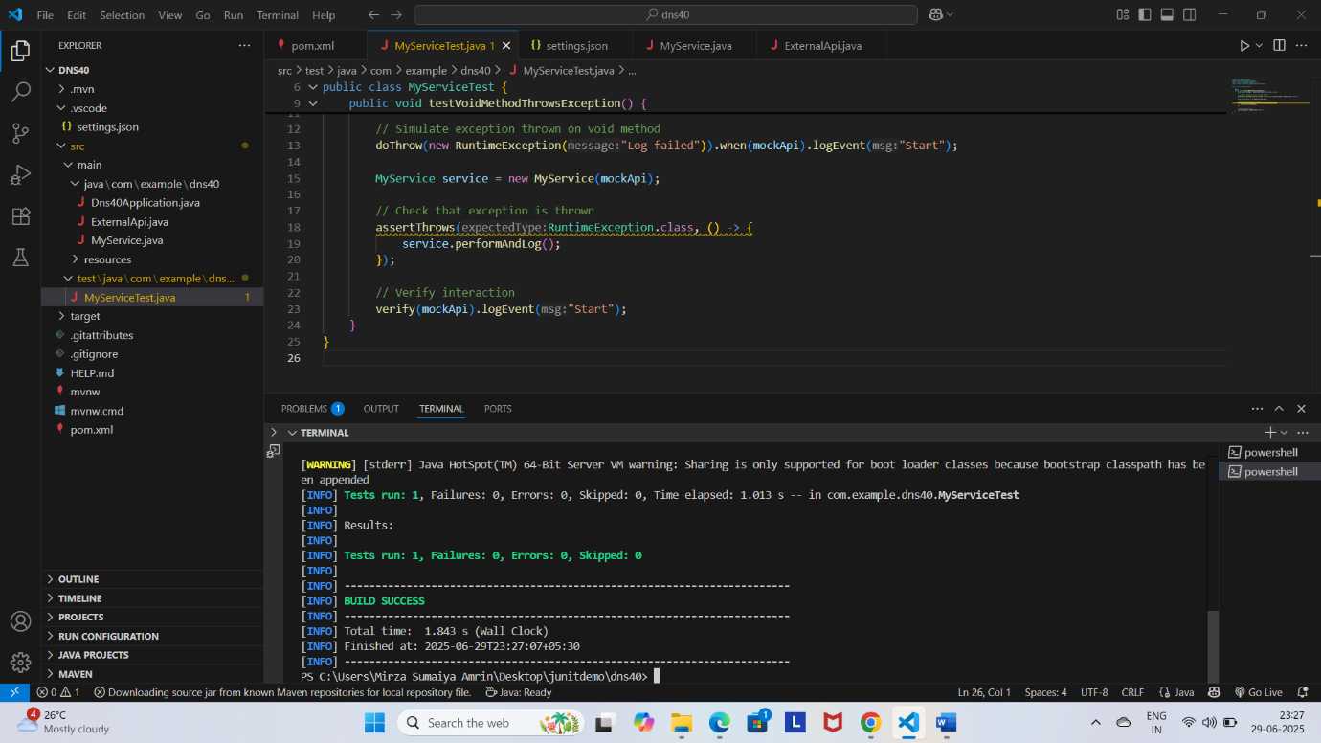

**3.1**

**Exercise 1:**

**MyService.java**

package com.example.dns40;

class Service {

    private final Repository repository;

    public Service(Repository repository) {

        this.repository = repository;

    }

    public String processData() {

        return "Processed " + repository.getData();

    }

}

**Repository.java**

package com.example.dns40;

interface Repository {

    String getData();

}

**MyServiceTest.java**

package com.example.dns40;

import static org.junit.jupiter.api.Assertions.assertEquals;

import org.junit.jupiter.api.Test;

import static org.mockito.Mockito.mock;

import static org.mockito.Mockito.when;

public class MyServiceTest {

    @Test

    public void testServiceWithMockRepository() {

        Repository mockRepository = mock(Repository.class);

        when(mockRepository.getData()).thenReturn("Mock Data");

        Service service = new Service(mockRepository);

        String result = service.processData();

        assertEquals("Processed Mock Data", result);

    }

}

**Output:**

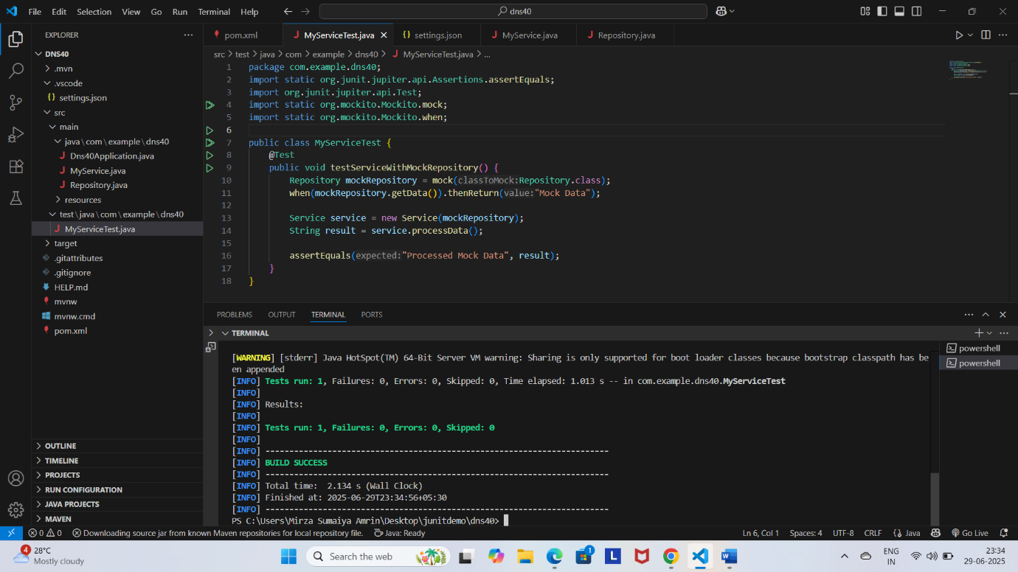

**Exercise 2:**

**RestClient.java**

package com.example.dns40;

interface RestClient {

    String getResponse();

}

**ApiService.java**

package com.example.dns40;

class ApiService {

    private final RestClient restClient;

    public ApiService(RestClient restClient) {

        this.restClient = restClient;

    }

    public String fetchData() {

        return "Fetched " + restClient.getResponse();

    }

}

**ApiServiceTest.java**

package com.example.dns40;

import static org.junit.jupiter.api.Assertions.assertEquals;

import org.junit.jupiter.api.Test;

import static org.mockito.Mockito.mock;

import static org.mockito.Mockito.when;

class ApiServiceTest {

    @Test

    public void testServiceWithMockRestClient() {

        RestClient mockRestClient = mock(RestClient.class);

        when(mockRestClient.getResponse()).thenReturn("Mock Response");

        ApiService apiService = new ApiService(mockRestClient);

        String result = apiService.fetchData();

        assertEquals("Fetched Mock Response", result);

    }

}

**Output:**

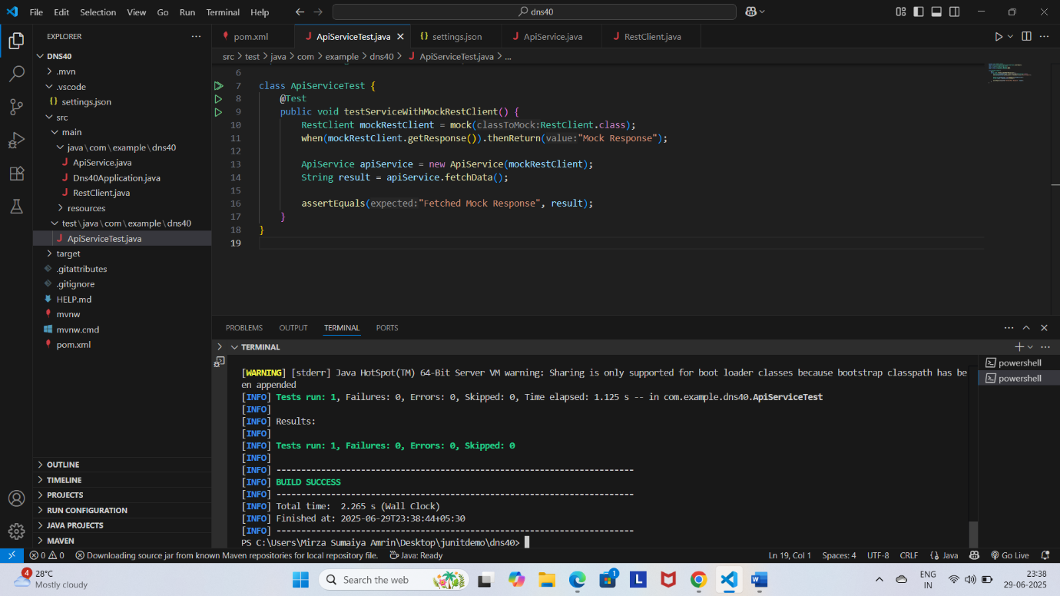

**Exercise 3:**

**FileService.java**

package com.example.dns40;

class FileService {

    private final FileReader fileReader;

    private final FileWriter fileWriter;

    public FileService(FileReader fileReader, FileWriter fileWriter) {

        this.fileReader = fileReader;

        this.fileWriter = fileWriter;

    }

    public String processFile() {

        String content = fileReader.read();

        fileWriter.write("Processed " + content);

        return "Processed " + content;

    }

}

**FileReader.java**

package com.example.dns40;

interface FileReader {

    String read();

}

**FileWriter.java**

package com.example.dns40;

interface FileWriter {

    void write(String content);

}

**FileServiceTest.java**

import static org.junit.jupiter.api.Assertions.assertEquals;

import org.junit.jupiter.api.Test;

import static org.mockito.Mockito.mock;

import static org.mockito.Mockito.verify;

import static org.mockito.Mockito.when;

class FileServiceTest {

    @Test

    public void testServiceWithMockFileIO() {

        FileReader mockFileReader = mock(FileReader.class);

        FileWriter mockFileWriter = mock(FileWriter.class);

        when(mockFileReader.read()).thenReturn("Mock File Content");

        FileService fileService = new FileService(mockFileReader, mockFileWriter);

        String result = fileService.processFile();

        assertEquals("Processed Mock File Content", result);

        verify(mockFileWriter).write("Processed Mock File Content");

    }

}

**Output:**

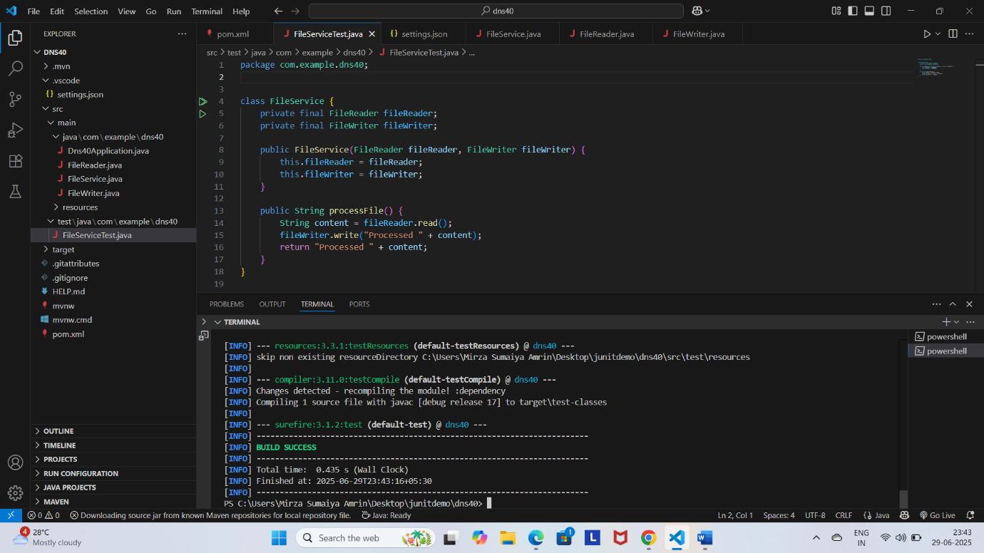

**Exercise 4:**

**NetworkService.java**

package com.example.dns40;

class NetworkService {

    private final NetworkClient networkClient;

    public NetworkService(NetworkClient networkClient) {

        this.networkClient = networkClient;

    }

    public String connectToServer() {

        return "Connected to " + networkClient.connect();

    }

}

**NetworkClient.java**

package com.example.dns40;

interface NetworkClient {

    String connect();

}

**NetworkServiceTest.java**

package com.example.dns40;

import static org.junit.jupiter.api.Assertions.assertEquals;

import org.junit.jupiter.api.Test;

import static org.mockito.Mockito.mock;

import static org.mockito.Mockito.when;

class NetworkServiceTest {

    @Test

    public void testServiceWithMockNetworkClient() {

        NetworkClient mockNetworkClient = mock(NetworkClient.class);

        when(mockNetworkClient.connect()).thenReturn("Mock Connection");

        NetworkService networkService = new NetworkService(mockNetworkClient);

        String result = networkService.connectToServer();

        assertEquals("Connected to Mock Connection", result);

    }

}

**Output:**



**Exercise 5:**

**Service.java**

package com.example.dns40;

class Service {

    private final Repository repository;

    public Service(Repository repository) {

        this.repository = repository;

    }

    public String processData() {

        return "Processed " + repository.getData();

    }

}

**Repository.java**

package com.example.dns40;

interface Repository {

    String getData();

}

**MultiReturnServiceTest.java**

package com.example.dns40;

import static org.junit.jupiter.api.Assertions.assertEquals;

import org.junit.jupiter.api.Test;

import static org.mockito.Mockito.mock;

import static org.mockito.Mockito.when;

public class MultiReturnServiceTest {

    @Test

    public void testServiceWithMultipleReturnValues() {

        Repository mockRepository = mock(Repository.class);

        when(mockRepository.getData())

            .thenReturn("First Mock Data")

            .thenReturn("Second Mock Data");

        Service service = new Service(mockRepository);

        String firstResult = service.processData();

        String secondResult = service.processData();

        assertEquals("Processed First Mock Data", firstResult);

        assertEquals("Processed Second Mock Data", secondResult);

    }

}

**Output:**

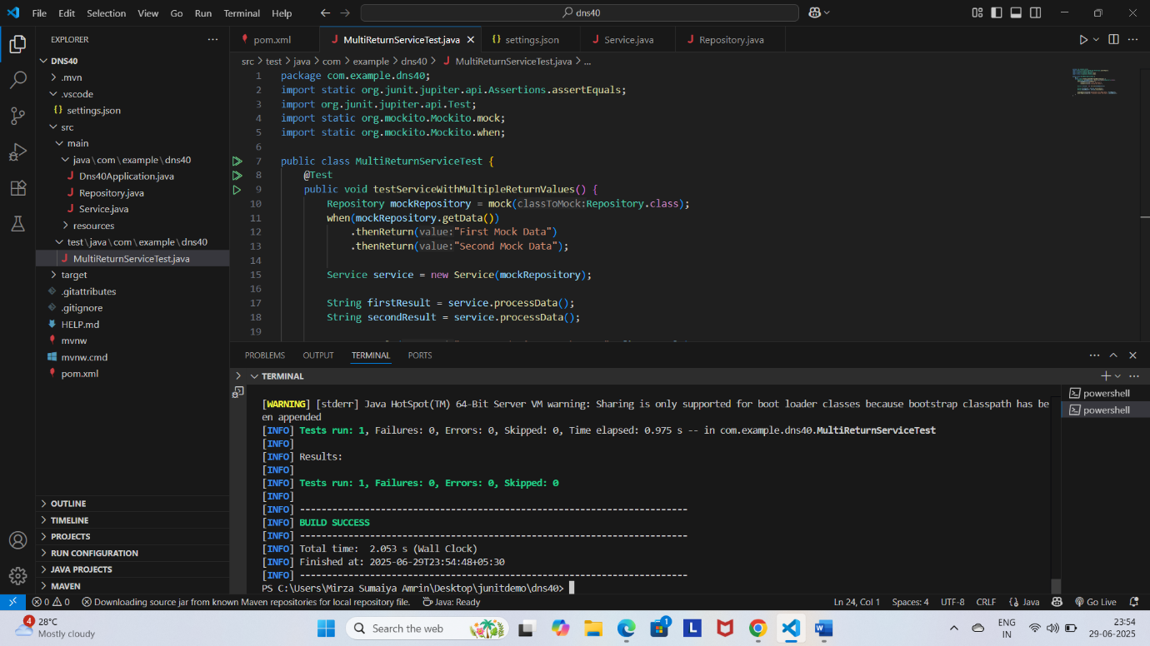

**4.**

**Exercise 1:**

**CalculatorService.java**

package com.example.dns40;

import org.springframework.stereotype.Service;

@Service

class CalculatorService {

    public int add(int a, int b) {

        return a + b;

    }

}

**CalculatorServiceTest.java**

package com.example.dns40;

import static org.junit.jupiter.api.Assertions.assertEquals;

import org.junit.jupiter.api.Test;

class CalculatorServiceTest {

    @Test

    void testAdd() {

        CalculatorService calculatorService = new CalculatorService();

        assertEquals(5, calculatorService.add(2, 3));

        assertEquals(0, calculatorService.add(-1, 1));

    }

}

**Output:**

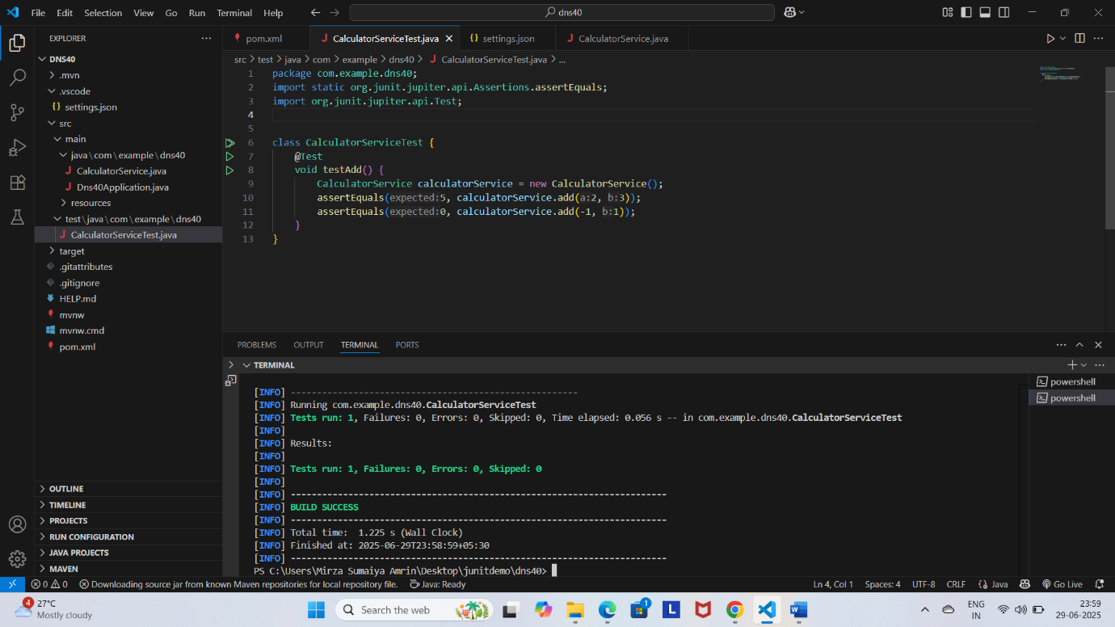

**Exercise 2:**

**User.java**

package com.example.dns40;

import jakarta.persistence.Entity;

import jakarta.persistence.GeneratedValue;

import jakarta.persistence.GenerationType;

import jakarta.persistence.Id;

@Entity

public class User {

    @Id

    @GeneratedValue(strategy = GenerationType.IDENTITY)

    private Long id;

    private String name;

    // Constructors

    public User() {

    }

    public User(Long id, String name) {

        this.id = id;

        this.name = name;

    }

    // Getters and Setters

    public Long getId() { return id; }

    public void setId(Long id) { this.id = id; }

    public String getName() { return name; }

    public void setName(String name) { this.name = name; }

}

**UserRepository.java**

package com.example.dns40;

import org.springframework.data.jpa.repository.JpaRepository;

interface UserRepository extends JpaRepository<User, Long> {}

**UserService.java**

package com.example.dns40;

import org.springframework.beans.factory.annotation.Autowired;

import org.springframework.stereotype.Service;

@Service

class UserService {

    private final UserRepository userRepository;

    @Autowired

    public UserService(UserRepository userRepository) {

        this.userRepository = userRepository;

    }

    public User getUserById(Long id) {

        return userRepository.findById(id).orElse(null);

    }

    public User saveUser(User user) {

        return userRepository.save(user);

    }

}

**UserServiceTest.java**

package com.example.dns40;

import java.util.Optional;

import static org.junit.jupiter.api.Assertions.assertEquals;

import static org.junit.jupiter.api.Assertions.assertNotNull;

import org.junit.jupiter.api.Test;

import static org.mockito.Mockito.mock;

import static org.mockito.Mockito.when;

class UserServiceTest {

    @Test

    void testGetUserById() {

        UserRepository mockRepo = mock(UserRepository.class);

        User user = new User();

        user.setId(1L);

        user.setName("John");

        when(mockRepo.findById(1L)).thenReturn(Optional.of(user));

        UserService service = new UserService(mockRepo);

        User result = service.getUserById(1L);

        assertNotNull(result);

        assertEquals("John", result.getName());

    }

}

**Output:**

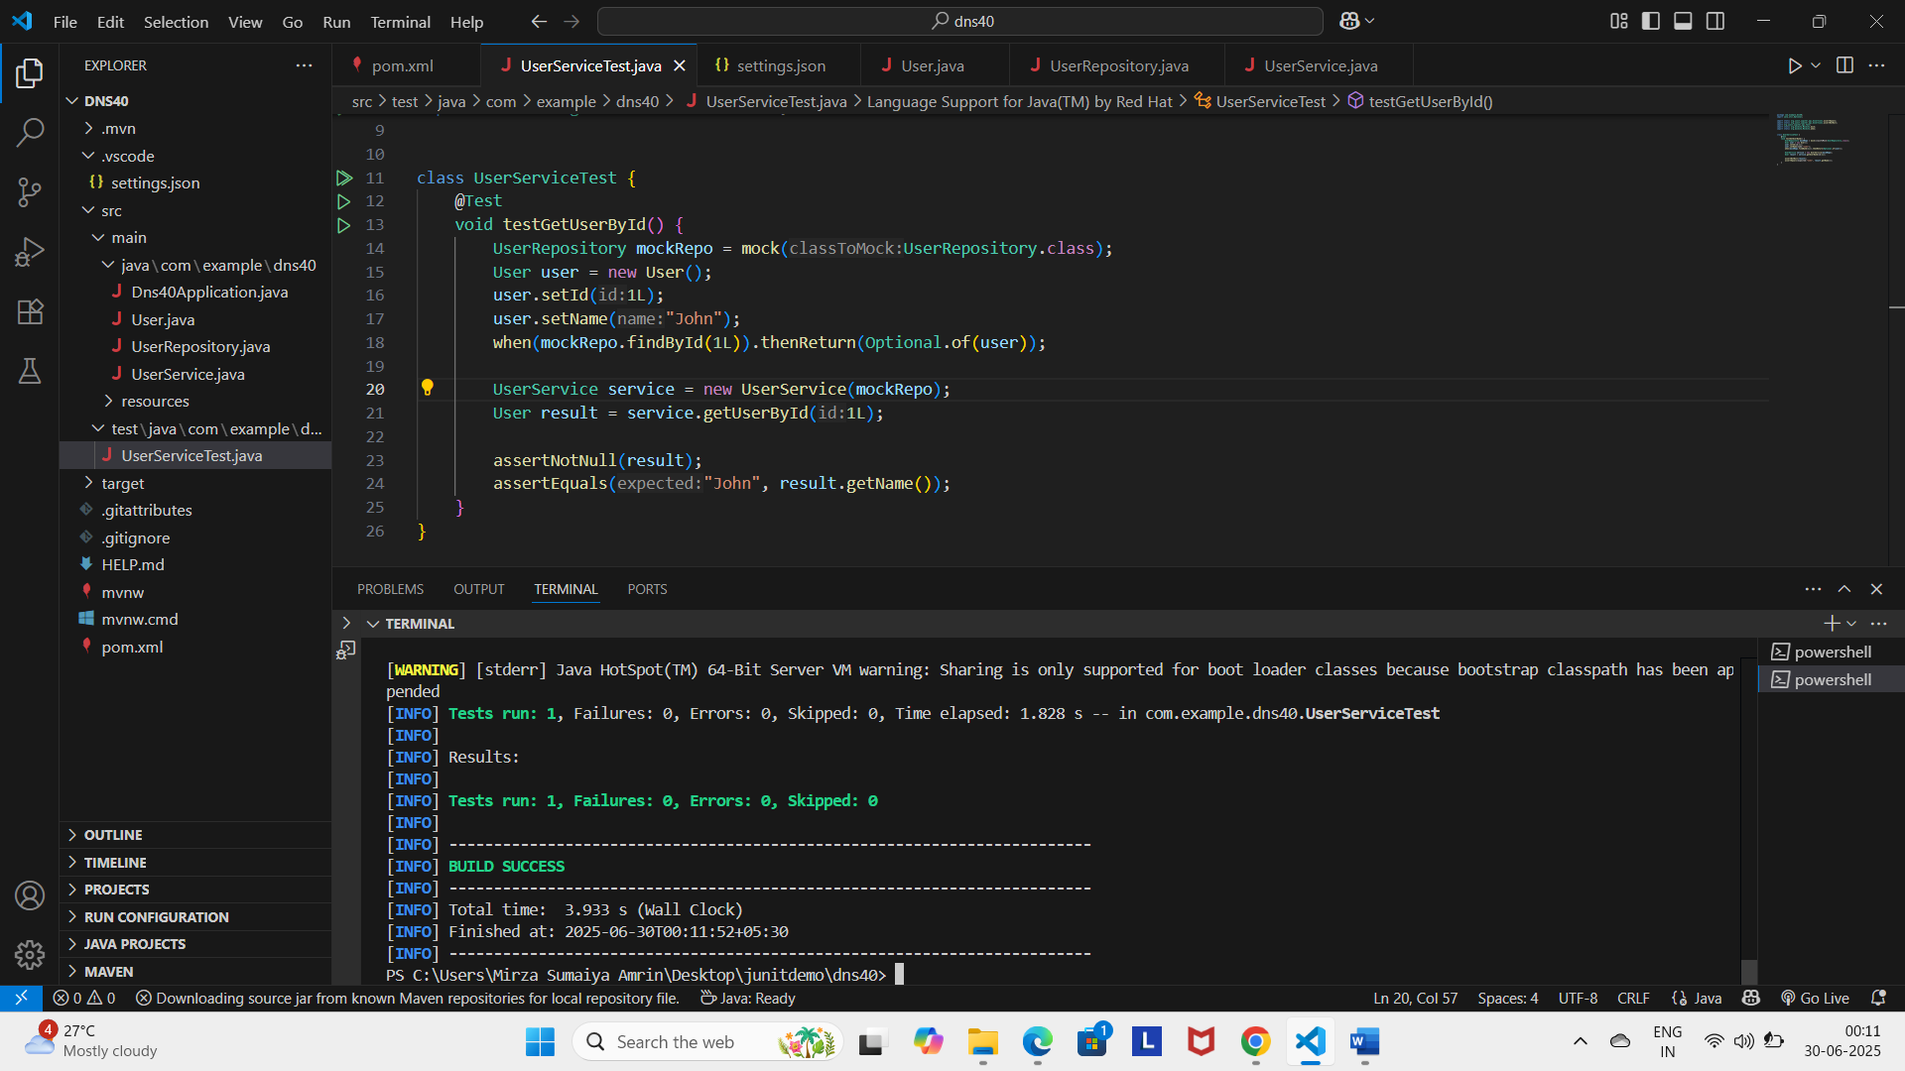

**Exercise 3:**

**User.java**

package com.example.dns40;

import jakarta.persistence.Entity;

import jakarta.persistence.Id;

@Entity

public class User {

    @Id

    private Long id;

    private String name;

    public User() {}

    public User(Long id, String name) {

        this.id = id;

        this.name = name;

    }

    // Getters and setters

    public Long getId() { return id; }

    public void setId(Long id) { this.id = id; }

    public String getName() { return name; }

    public void setName(String name) { this.name = name; }

}

**UserService.java**

package com.example.dns40;

public interface UserService {

    User getUserById(Long id);

    User saveUser(User user);

}

**UserServiceImpl.java**

package com.example.dns40;

import java.util.NoSuchElementException;

import org.springframework.beans.factory.annotation.Autowired;

import org.springframework.stereotype.Service;

@Service

public class UserServiceImpl implements UserService {

    @Autowired

    private UserRepository userRepository;

    @Override

    public User getUserById(Long id) {

        return userRepository.findById(id)

                .orElseThrow(() -> new NoSuchElementException("User not found"));

    }

    @Override

    public User saveUser(User user) {

        return userRepository.save(user);

    }

}

**UserController.java**

package com.example.dns40;

import org.springframework.beans.factory.annotation.Autowired;

import org.springframework.http.ResponseEntity;

import org.springframework.web.bind.annotation.GetMapping;

import org.springframework.web.bind.annotation.PathVariable;

import org.springframework.web.bind.annotation.RequestMapping;

import org.springframework.web.bind.annotation.RestController;

@RestController

@RequestMapping("/users")

public class UserController {

    @Autowired

    private UserService userService;

    @GetMapping("/{id}")

    public ResponseEntity<User> getUser(@PathVariable Long id) {

        User user = userService.getUserById(id);

        return ResponseEntity.ok(user);

    }

}

**UserRepository.java**

package com.example.dns40;

import java.util.List;

import org.springframework.data.jpa.repository.JpaRepository;

public interface UserRepository extends JpaRepository<User, Long> {

    List<User> findByName(String name);

}

**UserControllerTest.java**

package com.example.dns40;

import org.junit.jupiter.api.Test;

import static org.mockito.Mockito.when;

import org.springframework.beans.factory.annotation.Autowired;

import org.springframework.boot.test.autoconfigure.web.servlet.WebMvcTest;

import org.springframework.boot.test.mock.mockito.MockBean;

import org.springframework.test.web.servlet.MockMvc;

import static org.springframework.test.web.servlet.request.MockMvcRequestBuilders.get;

import static org.springframework.test.web.servlet.result.MockMvcResultMatchers.jsonPath;

import static org.springframework.test.web.servlet.result.MockMvcResultMatchers.status;

@WebMvcTest(UserController.class)

class UserControllerTest {

    @Autowired

    private MockMvc mockMvc;

    @MockBean

    private UserService userService;

    @Test

    void testGetUser() throws Exception {

        User mockUser = new User(1L, "John Doe");

        when(userService.getUserById(1L)).thenReturn(mockUser);

        mockMvc.perform(get("/users/1"))

                .andExpect(status().isOk())

                .andExpect(jsonPath("$.id").value(1L))

                .andExpect(jsonPath("$.name").value("John Doe"));

    }

}

**pom.xml**

<dependencies>

        <!-- Spring Boot Starter -->

        <dependency>

            <groupId>org.springframework.boot</groupId>

            <artifactId>spring-boot-starter</artifactId>

        </dependency>

        <!-- Spring Boot Starter Test (includes JUnit 5 and Mockito) -->

        <dependency>

            <groupId>org.springframework.boot</groupId>

            <artifactId>spring-boot-starter-test</artifactId>

            <scope>test</scope>

            <exclusions>

                <exclusion>

                    <groupId>org.junit.vintage</groupId>

                    <artifactId>junit-vintage-engine</artifactId>

                </exclusion>

            </exclusions>

        </dependency>

        <dependency>

        <groupId>org.junit.jupiter</groupId>

        <artifactId>junit-jupiter-api</artifactId>

        <scope>test</scope>

    </dependency>

    <!-- ✅ Optional: JUnit Jupiter Engine (if running tests from command line) -->

    <dependency>

        <groupId>org.junit.jupiter</groupId>

        <artifactId>junit-jupiter-engine</artifactId>

        <scope>test</scope>

    </dependency>

<!-- Spring Data JPA: for JpaRepository -->

<dependency>

    <groupId>org.springframework.boot</groupId>

    <artifactId>spring-boot-starter-data-jpa</artifactId>

</dependency>

<!-- H2 Database: in-memory DB for testing (optional but useful) -->

<dependency>

    <groupId>com.h2database</groupId>

    <artifactId>h2</artifactId>

    <scope>runtime</scope>

</dependency>

<dependency>

    <groupId>jakarta.persistence</groupId>

    <artifactId>jakarta.persistence-api</artifactId>

</dependency>

<!-- Spring Boot Web Starter -->

<dependency>

    <groupId>org.springframework.boot</groupId>

    <artifactId>spring-boot-starter-web</artifactId>

</dependency>

    </dependencies>

**Output:**

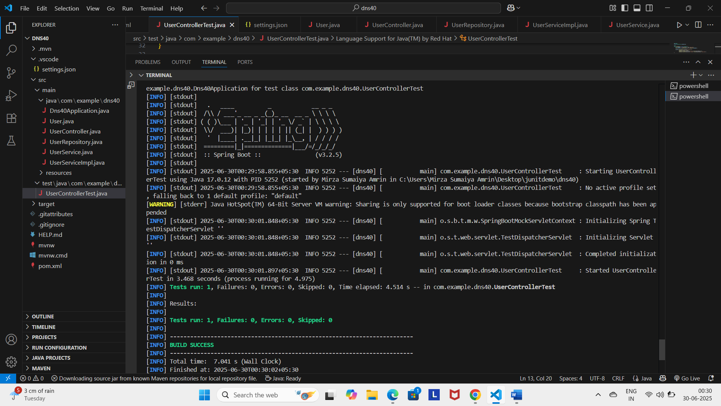

**Exercise 4:**

**User.java**

package com.example.dns40;

import jakarta.persistence.Entity;

import jakarta.persistence.GeneratedValue;

import jakarta.persistence.GenerationType;

import jakarta.persistence.Id;

import jakarta.persistence.Table;

@Entity

@Table(name = "users")

public class User {

    @Id

    @GeneratedValue(strategy = GenerationType.IDENTITY)

    private Long id;

    private String name;

    // Required by JPA

    public User() {}

    public User(Long id, String name) {

        this.id = id;

        this.name = name;

    }

    public User(String name) {

        this.name = name;

    }

    // Getters and Setters

    public Long getId() {

        return id;

    }

    public String getName() {

        return name;

    }

    public void setId(Long id) {

        this.id = id;

    }

    public void setName(String name) {

        this.name = name;

    }

}

**UserService.java**

package com.example.dns40;

public interface UserService {

    User getUserById(Long id);

    User saveUser(User user);

}

**UserServiceImpl.java**

package com.example.dns40;

import java.util.NoSuchElementException;

import org.springframework.beans.factory.annotation.Autowired;

import org.springframework.stereotype.Service;

@Service

public class UserServiceImpl implements UserService {

    @Autowired

    private UserRepository userRepository;

    @Override

    public User getUserById(Long id) {

        return userRepository.findById(id)

                .orElseThrow(() -> new NoSuchElementException("User not found"));

    }

    @Override

    public User saveUser(User user) {

        return userRepository.save(user);

    }

}

**UserRepository.java**

package com.example.dns40;

import org.springframework.data.jpa.repository.JpaRepository;

public interface UserRepository extends JpaRepository<User, Long> {

}

**UserController.java**

package com.example.dns40;

import org.springframework.beans.factory.annotation.Autowired;

import org.springframework.http.ResponseEntity;

import org.springframework.web.bind.annotation.GetMapping;

import org.springframework.web.bind.annotation.PathVariable;

import org.springframework.web.bind.annotation.PostMapping;

import org.springframework.web.bind.annotation.RequestBody;

import org.springframework.web.bind.annotation.RequestMapping;

import org.springframework.web.bind.annotation.RestController;

@RestController

@RequestMapping("/users")

public class UserController {

    @Autowired

    private UserService userService;

    @GetMapping("/{id}")

    public ResponseEntity<User> getUser(@PathVariable Long id) {

        return ResponseEntity.ok(userService.getUserById(id));

    }

    @PostMapping

    public ResponseEntity<User> createUser(@RequestBody User user) {

        return ResponseEntity.ok(userService.saveUser(user));

    }

}

**GlobalExceptionHandler.java**

package com.example.dns40;

import java.util.NoSuchElementException;

import org.springframework.http.HttpStatus;

import org.springframework.http.ResponseEntity;

import org.springframework.web.bind.annotation.ControllerAdvice;

import org.springframework.web.bind.annotation.ExceptionHandler;

@ControllerAdvice

public class GlobalExceptionHandler {

    @ExceptionHandler(NoSuchElementException.class)

    public ResponseEntity<String> handleNoSuchElement(NoSuchElementException ex) {

        return ResponseEntity.status(HttpStatus.NOT_FOUND).body(ex.getMessage());

    }

}

**UserIntegrationTest.java**

package com.example.dns40;

import org.junit.jupiter.api.BeforeEach;

import org.junit.jupiter.api.Test;

import org.springframework.beans.factory.annotation.Autowired;

import org.springframework.boot.test.autoconfigure.web.servlet.AutoConfigureMockMvc;

import org.springframework.boot.test.context.SpringBootTest;

import org.springframework.http.MediaType;

import org.springframework.test.web.servlet.MockMvc;

import static org.springframework.test.web.servlet.request.MockMvcRequestBuilders.get;

import static org.springframework.test.web.servlet.request.MockMvcRequestBuilders.post;

import static org.springframework.test.web.servlet.result.MockMvcResultMatchers.jsonPath;

import static org.springframework.test.web.servlet.result.MockMvcResultMatchers.status;

@SpringBootTest

@AutoConfigureMockMvc

public class UserIntegrationTest {

    @Autowired

    private MockMvc mockMvc;

    @Autowired

    private UserRepository userRepository;

    private Long testUserId;

    @BeforeEach

    void setup() {

        userRepository.deleteAll();

        User savedUser = userRepository.save(new User("John Doe"));

        testUserId = savedUser.getId();

    }

    @Test

    void testGetUserIntegration() throws Exception {

        mockMvc.perform(get("/users/" + testUserId))

                .andExpect(status().isOk())

                .andExpect(jsonPath("$.name").value("John Doe"));

    }

    @Test

    void testCreateUserIntegration() throws Exception {

        String userJson = "{\"name\":\"Alice\"}";

        mockMvc.perform(post("/users")

                .contentType(MediaType.APPLICATION_JSON)

                .content(userJson))

                .andExpect(status().isOk())

                .andExpect(jsonPath("$.name").value("Alice"));

    }

}

**Output:**

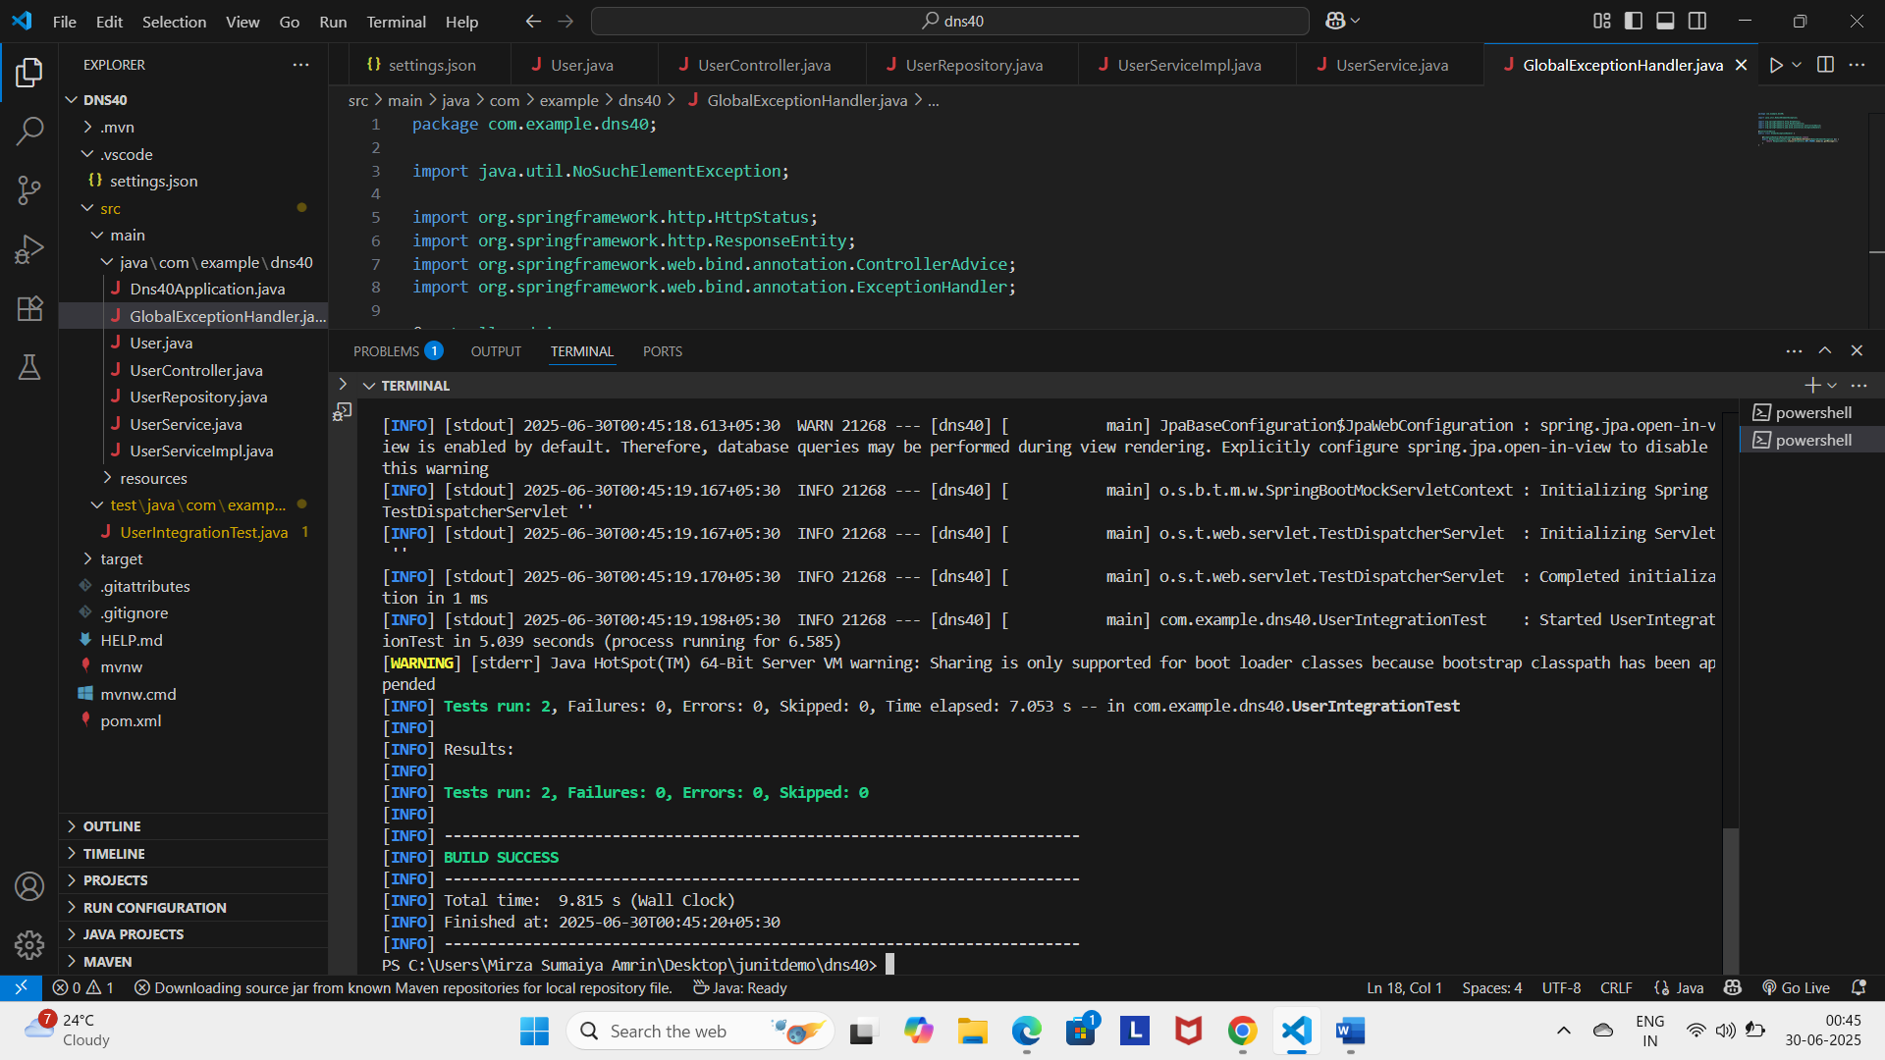

**Exercise 5:**

**User.java**

package com.example.dns40;

import jakarta.persistence.Entity;

import jakarta.persistence.GeneratedValue;

import jakarta.persistence.GenerationType;

import jakarta.persistence.Id;

import jakarta.persistence.Table;

@Entity

@Table(name = "users")

public class User {

    @Id

    @GeneratedValue(strategy = GenerationType.IDENTITY)

    private Long id;

    private String name;

    public User() {}

    public User(Long id, String name) {

        this.id = id;

        this.name = name;

    }

    public User(String name) {

        this.name = name;

    }

    // Getters and Setters

    public Long getId() { return id; }

    public String getName() { return name; }

    public void setId(Long id) { this.id = id; }

    public void setName(String name) { this.name = name; }

}

**UserSerivice.java**

package com.example.dns40;

public interface UserService {

    User saveUser(User user);

}

**UserSeriveImpl.java**

package com.example.dns40;

import org.springframework.beans.factory.annotation.Autowired;

import org.springframework.stereotype.Service;

@Service

public class UserServiceImpl implements UserService {

    @Autowired

    private UserRepository userRepository;

    @Override

    public User saveUser(User user) {

        return userRepository.save(user);

    }

}

**UserController.java**

package com.example.dns40;

import org.springframework.beans.factory.annotation.Autowired;

import org.springframework.http.ResponseEntity;

import org.springframework.web.bind.annotation.PostMapping;

import org.springframework.web.bind.annotation.RequestBody;

import org.springframework.web.bind.annotation.RequestMapping;

import org.springframework.web.bind.annotation.RestController;

@RestController

@RequestMapping("/users")

public class UserController {

    @Autowired

    private UserService userService;

    @PostMapping

    public ResponseEntity<User> createUser(@RequestBody User user) {

        return ResponseEntity.ok(userService.saveUser(user));

    }

}

**UserControllerPostTest.java**

package com.example.dns40;

import org.junit.jupiter.api.Test;

import static org.mockito.ArgumentMatchers.any;

import static org.mockito.Mockito.when;

import org.springframework.beans.factory.annotation.Autowired;

import org.springframework.boot.test.autoconfigure.web.servlet.WebMvcTest;

import org.springframework.boot.test.mock.mockito.MockBean;

import org.springframework.http.MediaType;

import org.springframework.test.web.servlet.MockMvc;

import static org.springframework.test.web.servlet.request.MockMvcRequestBuilders.post;

import static org.springframework.test.web.servlet.result.MockMvcResultMatchers.jsonPath;

import static org.springframework.test.web.servlet.result.MockMvcResultMatchers.status;

import com.fasterxml.jackson.databind.ObjectMapper;

@WebMvcTest(UserController.class)

public class UserControllerPostTest {

    @Autowired

    private MockMvc mockMvc;

    @MockBean

    private UserService userService;

    private final ObjectMapper objectMapper = new ObjectMapper();

    @Test

    void testCreateUser() throws Exception {

        User inputUser = new User(null, "Alice");

        User savedUser = new User(1L, "Alice");

        when(userService.saveUser(any(User.class))).thenReturn(savedUser); // ✅ Use `any()`

        mockMvc.perform(post("/users")

                        .contentType(MediaType.APPLICATION_JSON)

                        .content(objectMapper.writeValueAsString(inputUser)))

                .andExpect(status().isOk())

                .andExpect(jsonPath("$.id").value(1L))

                .andExpect(jsonPath("$.name").value("Alice"));

    }

}

**UserRepository.java**

package com.example.dns40;

import org.springframework.data.jpa.repository.JpaRepository;

public interface UserRepository extends JpaRepository<User, Long> {

}

**Output:**

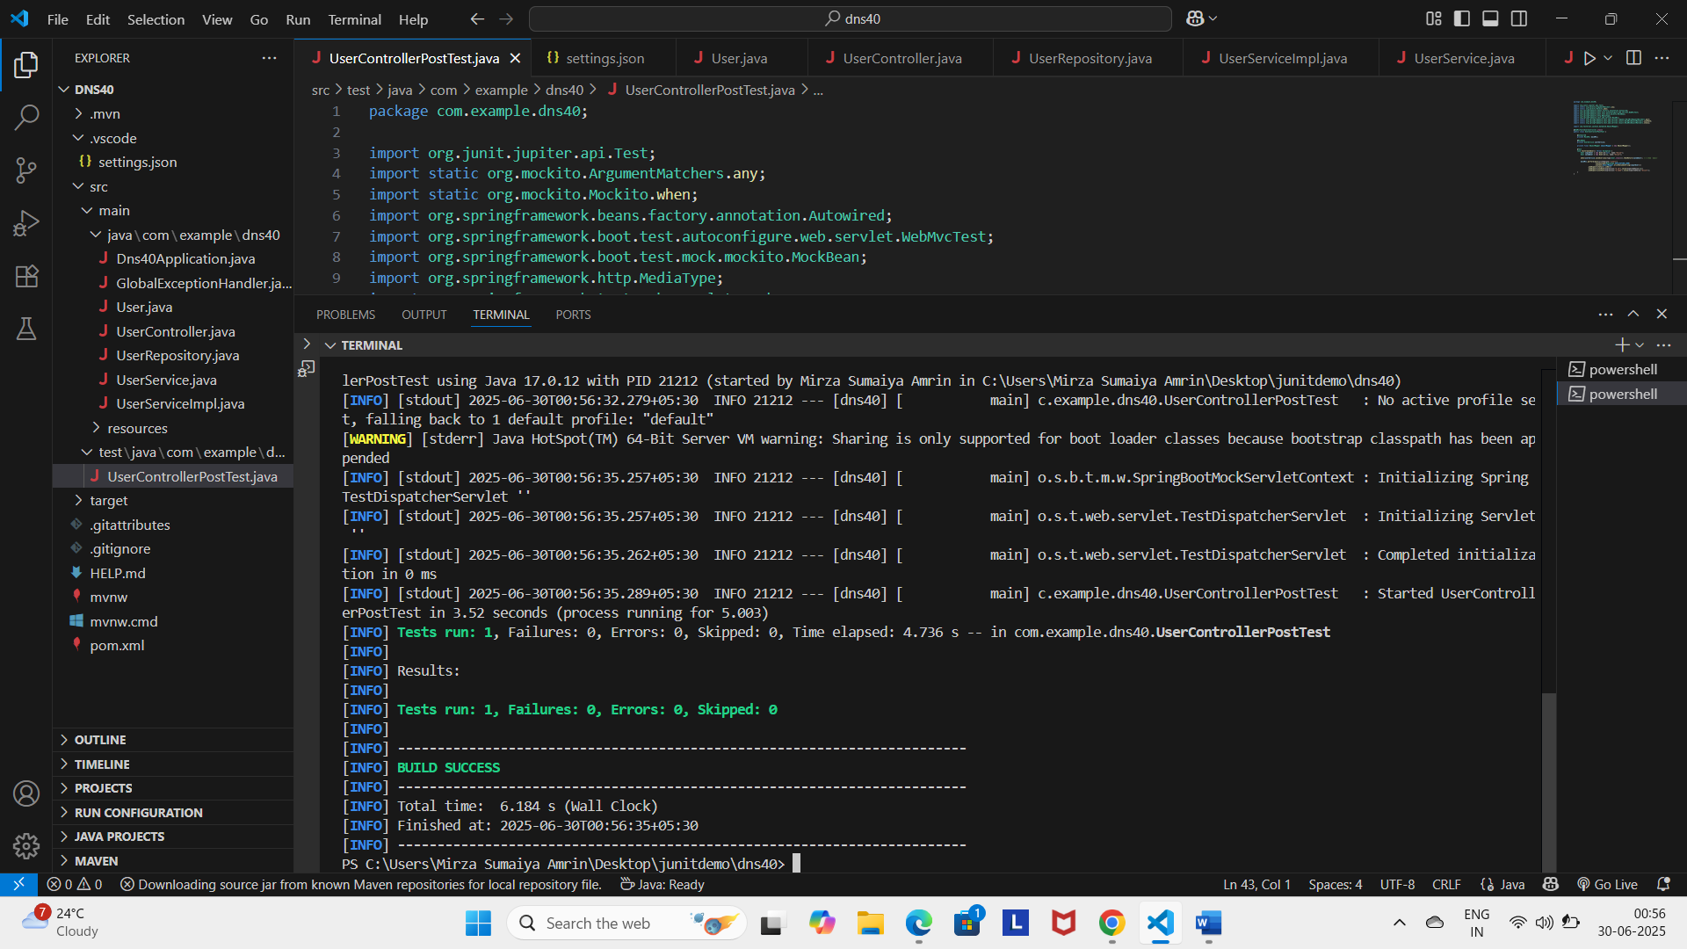

**Exercise 6:**

**User.java**

package com.example.dns40;

import jakarta.persistence.Entity;

import jakarta.persistence.GeneratedValue;

import jakarta.persistence.GenerationType;

import jakarta.persistence.Id;

import jakarta.persistence.Table;

@Entity

@Table(name = "users")

public class User {

    @Id

    @GeneratedValue(strategy = GenerationType.IDENTITY)

    private Long id;

    private String name;

    public User() {}

    public User(Long id, String name) {

        this.id = id;

        this.name = name;

    }

    // Getters and setters...

}

**UserRepository.java**

package com.example.dns40;

import org.springframework.data.jpa.repository.JpaRepository;

public interface UserRepository extends JpaRepository<User, Long> {

}

**UserService.java**

package com.example.dns40;

public interface UserService {

    User getUserById(Long id);

    User saveUser(User user);

}

**UserServiceImpl.java**

package com.example.dns40;

import org.springframework.beans.factory.annotation.Autowired;

import org.springframework.stereotype.Service;

import java.util.Optional;

@Service

public class UserServiceImpl implements UserService {

    @Autowired

    private UserRepository userRepository;

    @Override

    public User getUserById(Long id) {

        return userRepository.findById(id)

            .orElseThrow(() -> new UserNotFoundException("User with id " + id + " not found"));

    }

    @Override

    public User saveUser(User user) {

        return userRepository.save(user);

    }

}

**UserNotFoundException.java**

package com.example.dns40;

public class UserNotFoundException extends RuntimeException {

    public UserNotFoundException(String message) {

        super(message);

    }

}

**GlobalExceptionHandler.java**

package com.example.dns40;

import org.springframework.http.HttpStatus;

import org.springframework.http.ResponseEntity;

import org.springframework.web.bind.annotation.*;

@ControllerAdvice

public class GlobalExceptionHandler {

    @ExceptionHandler(UserNotFoundException.class)

    public ResponseEntity<String> handleNotFound(UserNotFoundException ex) {

        return ResponseEntity.status(HttpStatus.NOT_FOUND).body(ex.getMessage());

    }

}

**UserController.java**

package com.example.dns40;

import org.springframework.beans.factory.annotation.Autowired;

import org.springframework.http.ResponseEntity;

import org.springframework.web.bind.annotation.*;

@RestController

@RequestMapping("/users")

public class UserController {

    @Autowired

    private UserService userService;

    @GetMapping("/{id}")

    public ResponseEntity<User> getUser(@PathVariable Long id) {

        User user = userService.getUserById(id);

        return ResponseEntity.ok(user);

    }

    @PostMapping

    public ResponseEntity<User> createUser(@RequestBody User user) {

        User saved = userService.saveUser(user);

        return ResponseEntity.ok(saved);

    }

}

**UserControllerExceptionTest.java**

package com.example.dns40;

import org.junit.jupiter.api.Test;

import static org.mockito.Mockito.when;

import static org.mockito.ArgumentMatchers.anyLong;

import org.springframework.beans.factory.annotation.Autowired;

import org.springframework.boot.test.autoconfigure.web.servlet.WebMvcTest;

import org.springframework.boot.test.mock.mockito.MockBean;

import org.springframework.test.web.servlet.MockMvc;

import static org.springframework.test.web.servlet.request.MockMvcRequestBuilders.get;

import static org.springframework.test.web.servlet.result.MockMvcResultMatchers.*;

@WebMvcTest(UserController.class)

public class UserControllerExceptionTest {

    @Autowired

    private MockMvc mockMvc;

    @MockBean

    private UserService userService;

    @Test

    void testUserNotFoundException() throws Exception {

        when(userService.getUserById(anyLong()))

            .thenThrow(new UserNotFoundException("User not found"));

        mockMvc.perform(get("/users/99"))

                .andExpect(status().isNotFound())

                .andExpect(content().string("User not found"));

    }

}

**Output:**

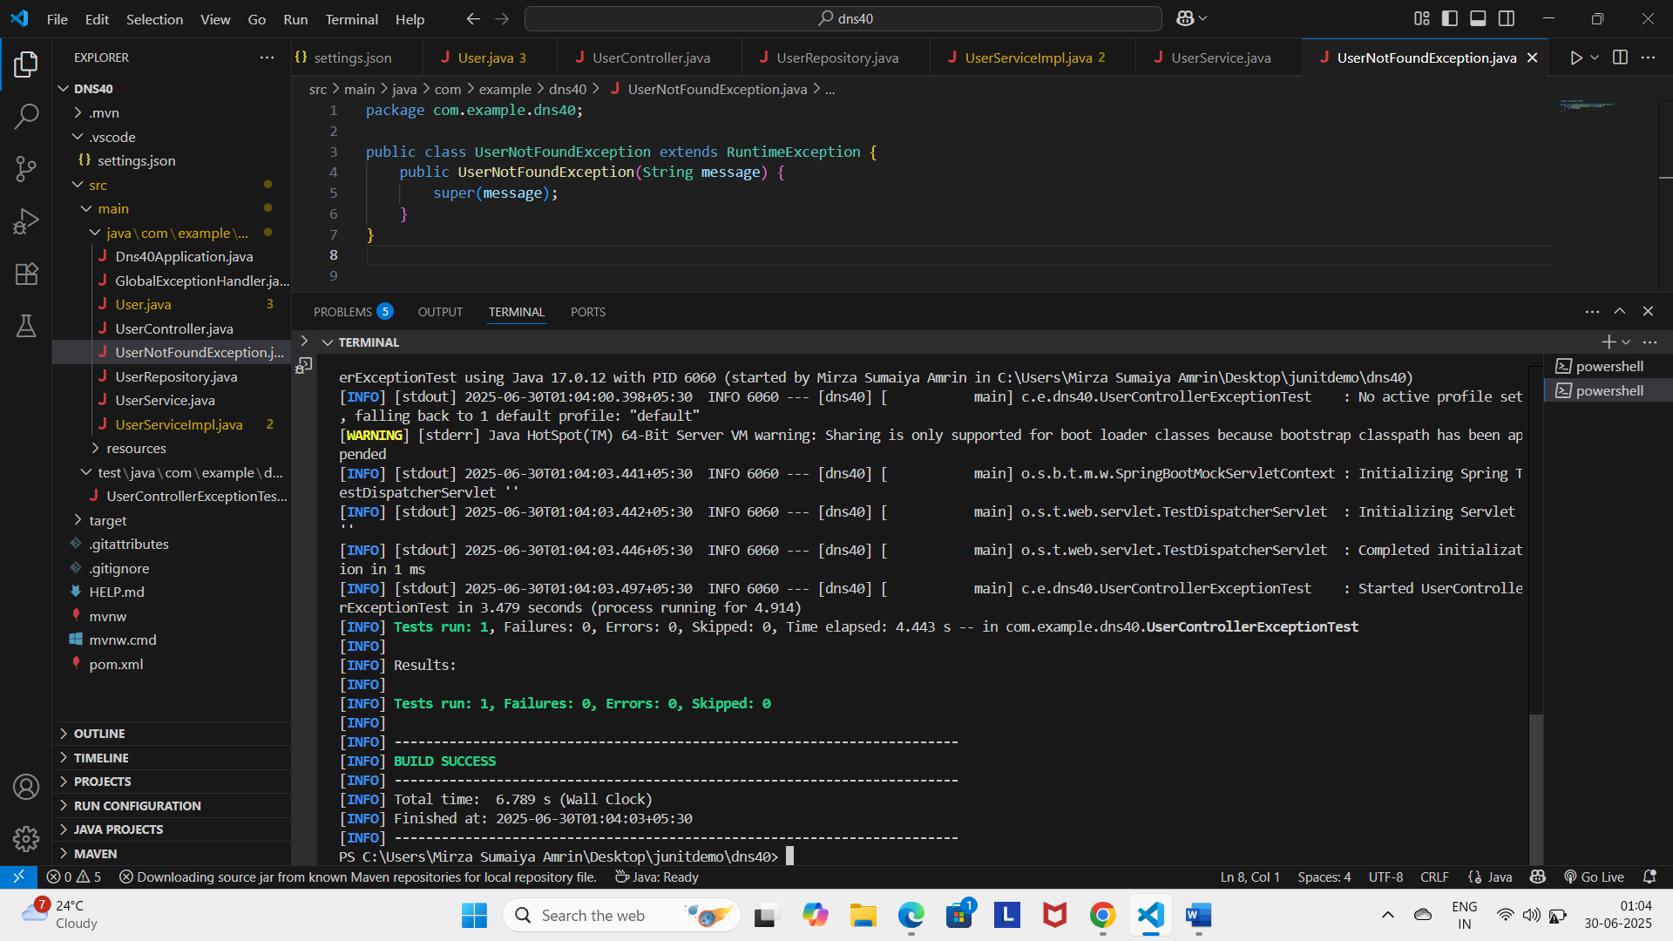

**Exercise 7:**

**User.java**

package com.example.dns40;

import jakarta.persistence.*;

import jakarta.validation.constraints.NotBlank;

@Entity

@Table(name = "users")

public class User {

    @Id

    @GeneratedValue(strategy = GenerationType.IDENTITY)

    private Long id;

    @NotBlank(message = "Name must not be blank")

    private String name;

    public User() {}

    public User(Long id, String name) {

        this.id = id;

        this.name = name;

    }

    // Getters and setters...

    public Long getId() {

        return id;

    }

    public String getName() {

        return name;

    }

    public void setId(Long id) {

        this.id = id;

    }

    public void setName(String name) {

        this.name = name;

    }

}

**UserRepository.java**

package com.example.dns40;

import org.springframework.data.jpa.repository.JpaRepository;

public interface UserRepository extends JpaRepository<User, Long> {

}

**UserService.java**

package com.example.dns40;

public interface UserService {

    User getUserById(Long id);

    User saveUser(User user);

}

**UserServiceImpl.java**

package com.example.dns40;

import org.springframework.beans.factory.annotation.Autowired;

import org.springframework.stereotype.Service;

@Service

public class UserServiceImpl implements UserService {

    @Autowired

    private UserRepository userRepository;

    @Override

    public User getUserById(Long id) {

        return userRepository.findById(id)

                .orElseThrow(() -> new UserNotFoundException("User with id " + id + " not found"));

    }

    @Override

    public User saveUser(User user) {

        return userRepository.save(user);

    }

}

**GlobalExceptionHandler.java**

package com.example.dns40;

import java.util.stream.Collectors;

import org.springframework.http.ResponseEntity;

import org.springframework.web.bind.MethodArgumentNotValidException;

import org.springframework.web.bind.annotation.ControllerAdvice;

import org.springframework.web.bind.annotation.ExceptionHandler;

@ControllerAdvice

public class GlobalExceptionHandler {

    @ExceptionHandler(UserNotFoundException.class)

    public ResponseEntity<String> handleNotFound(UserNotFoundException ex) {

        return ResponseEntity.status(404).body(ex.getMessage());

    }

    @ExceptionHandler(MethodArgumentNotValidException.class)

    public ResponseEntity<String> handleValidationErrors(MethodArgumentNotValidException ex) {

        String errors = ex.getBindingResult().getFieldErrors().stream()

                .map(error -> error.getField() + ": " + error.getDefaultMessage())

                .collect(Collectors.joining(", "));

        return ResponseEntity.badRequest().body(errors);

    }

}

**UserController.java**

package com.example.dns40;

import org.springframework.beans.factory.annotation.Autowired;

import org.springframework.http.ResponseEntity;

import org.springframework.web.bind.annotation.PostMapping;

import org.springframework.web.bind.annotation.RequestBody;

import org.springframework.web.bind.annotation.RequestMapping;

import org.springframework.web.bind.annotation.RestController;

import jakarta.validation.Valid;

@RestController

@RequestMapping("/users")

public class UserController {

    @Autowired

    private UserService userService;

    @PostMapping

    public ResponseEntity<User> createUser(@Valid @RequestBody User user) {

        User saved = userService.saveUser(user);

        return ResponseEntity.ok(saved);

    }

}

**UserValidationTest.java**

package com.example.dns40;

import org.springframework.beans.factory.annotation.Autowired;

import org.springframework.http.ResponseEntity;

import org.springframework.web.bind.annotation.PostMapping;

import org.springframework.web.bind.annotation.RequestBody;

import org.springframework.web.bind.annotation.RequestMapping;

import org.springframework.web.bind.annotation.RestController;

import jakarta.validation.Valid;

@RestController

@RequestMapping("/users")

public class UserController {

    @Autowired

    private UserService userService;

    @PostMapping

    public ResponseEntity<User> createUser(@Valid @RequestBody User user) {

        User saved = userService.saveUser(user);

        return ResponseEntity.ok(saved);

    }

}

**Output:**

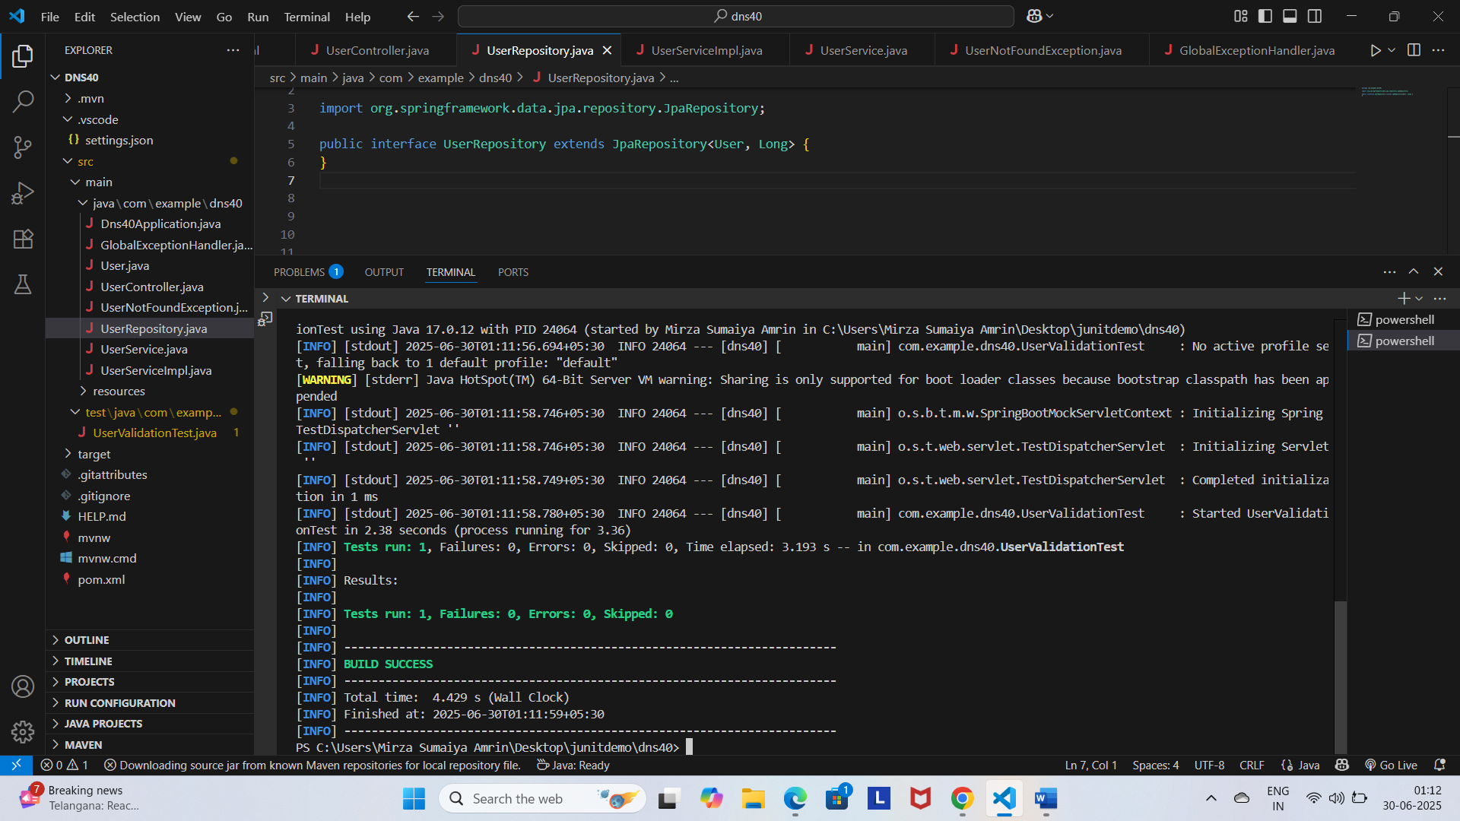

**Exercise 8:**

**User.java**

package com.example.dns40;

import jakarta.persistence.*;

import jakarta.validation.constraints.NotBlank;

@Entity

@Table(name = "users")

public class User {

    @Id

    @GeneratedValue(strategy = GenerationType.IDENTITY)

    private Long id;

    @NotBlank(message = "Name must not be blank")

    private String name;

    public User() {}

    public User(Long id, String name) {

        this.id = id;

        this.name = name;

    }

    // Getters and setters...

    public Long getId() {

        return id;

    }

    public String getName() {

        return name;

    }

    public void setId(Long id) {

        this.id = id;

    }

    public void setName(String name) {

        this.name = name;

    }

}

**UserRepository.java**

package com.example.dns40;

import java.util.Optional;

import org.springframework.data.jpa.repository.JpaRepository;

public interface UserRepository extends JpaRepository<User, Long> {

    Optional<User> findByName(String name);

}

**UserService.java**

package com.example.dns40;

import java.util.Optional;

public interface UserService {

    User getUserById(Long id);

    User saveUser(User user);

    Optional<User> findByName(String name);

}

**UserServiceImpl.java**

package com.example.dns40;

import org.springframework.beans.factory.annotation.Autowired;

import org.springframework.stereotype.Service;

import java.util.Optional;

@Service

public class UserServiceImpl implements UserService {

    @Autowired

    private UserRepository userRepository;

    @Override

    public User getUserById(Long id) {

        return userRepository.findById(id)

                .orElseThrow(() -> new UserNotFoundException("User with id " + id + " not found"));

    }

    @Override

    public User saveUser(User user) {

        return userRepository.save(user);

    }

    @Override

    public Optional<User> findByName(String name) {

        return userRepository.findByName(name);

    }

}

**UserNotFoundException.java**

package com.example.dns40;

public class UserNotFoundException extends RuntimeException {

    public UserNotFoundException(String message) {

        super(message);

    }

}

**GlobalExceptionHandler.java**

package com.example.dns40;

import java.util.stream.Collectors;

import org.springframework.http.ResponseEntity;

import org.springframework.web.bind.MethodArgumentNotValidException;

import org.springframework.web.bind.annotation.ControllerAdvice;

import org.springframework.web.bind.annotation.ExceptionHandler;

@ControllerAdvice

public class GlobalExceptionHandler {

    @ExceptionHandler(UserNotFoundException.class)

    public ResponseEntity<String> handleNotFound(UserNotFoundException ex) {

        return ResponseEntity.status(404).body(ex.getMessage());

    }

    @ExceptionHandler(MethodArgumentNotValidException.class)

    public ResponseEntity<String> handleValidationErrors(MethodArgumentNotValidException ex) {

        String errors = ex.getBindingResult().getFieldErrors().stream()

                .map(error -> error.getField() + ": " + error.getDefaultMessage())

                .collect(Collectors.joining(", "));

        return ResponseEntity.badRequest().body(errors);

    }

}

**UserController.java**

package com.example.dns40;

import org.springframework.beans.factory.annotation.Autowired;

import org.springframework.http.ResponseEntity;

import org.springframework.web.bind.annotation.*;

import java.util.Optional;

@RestController

@RequestMapping("/users")

public class UserController {

    @Autowired

    private UserService userService;

    @GetMapping("/{id}")

    public ResponseEntity<User> getUser(@PathVariable Long id) {

        User user = userService.getUserById(id);

        return ResponseEntity.ok(user);

    }

    @GetMapping("/search")

    public ResponseEntity<User> searchUserByName(@RequestParam String name) {

        Optional<User> userOpt = userService.findByName(name);

        return userOpt.map(ResponseEntity::ok)

                .orElse(ResponseEntity.notFound().build());

    }

}

**UserPathAndQueryParamTest.java**

package com.example.dns40;

import java.util.Optional;

import org.junit.jupiter.api.Test;

import static org.mockito.Mockito.when;

import org.springframework.beans.factory.annotation.Autowired;

import org.springframework.boot.test.autoconfigure.web.servlet.WebMvcTest;

import org.springframework.boot.test.mock.mockito.MockBean;

import org.springframework.test.web.servlet.MockMvc;

import static org.springframework.test.web.servlet.request.MockMvcRequestBuilders.get;

import static org.springframework.test.web.servlet.result.MockMvcResultMatchers.jsonPath;

import static org.springframework.test.web.servlet.result.MockMvcResultMatchers.status;

@WebMvcTest(UserController.class)

public class UserPathAndQueryParamTest {

    @Autowired

    private MockMvc mockMvc;

    @MockBean

    private UserService userService;

    @Test

    void testGetUserById() throws Exception {

        User user = new User(1L, "John");

        when(userService.getUserById(1L)).thenReturn(user);

        mockMvc.perform(get("/users/1"))

                .andExpect(status().isOk())

                .andExpect(jsonPath("$.name").value("John"));

    }

    @Test

    void testSearchUserByName() throws Exception {

        User user = new User(2L, "Alice");

        when(userService.findByName("Alice")).thenReturn(Optional.of(user));

        mockMvc.perform(get("/users/search?name=Alice"))

                .andExpect(status().isOk())

                .andExpect(jsonPath("$.id").value(2L))

                .andExpect(jsonPath("$.name").value("Alice"));

    }

    @Test

    void testSearchUserByNameNotFound() throws Exception {

        when(userService.findByName("Bob")).thenReturn(Optional.empty());

        mockMvc.perform(get("/users/search?name=Bob"))

                .andExpect(status().isNotFound());

    }

}

**Output:**

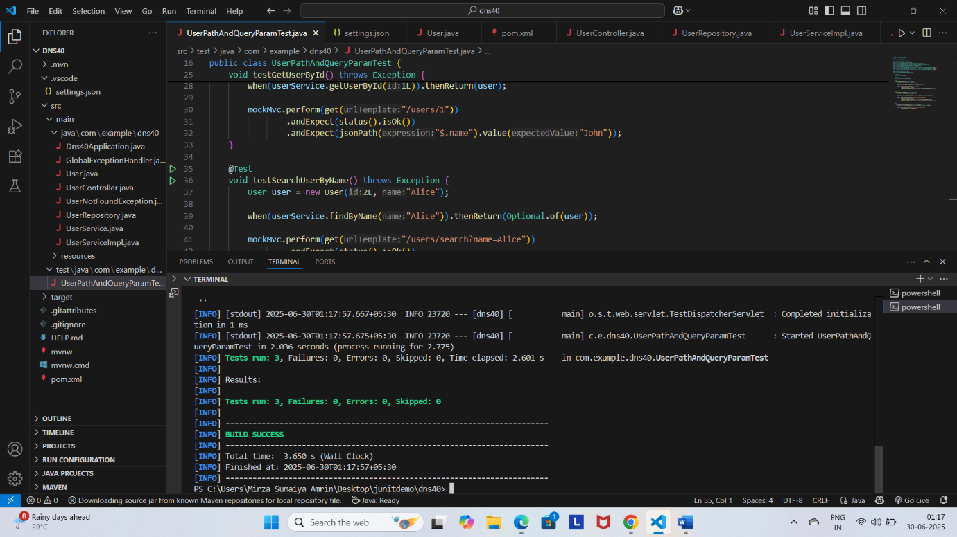

**Exercise 9:**

**User.java**

package com.example.dns40;

import jakarta.persistence.*;

import jakarta.validation.constraints.NotBlank;

@Entity

@Table(name = "users")

public class User {

    @Id

    @GeneratedValue(strategy = GenerationType.IDENTITY)

    private Long id;

    @NotBlank(message = "Name must not be blank")

    private String name;

    public User() {}

    public User(Long id, String name) {

        this.id = id;

        this.name = name;

    }

    // Getters and setters...

    public Long getId() {

        return id;

    }

    public String getName() {

        return name;

    }

    public void setId(Long id) {

        this.id = id;

    }

    public void setName(String name) {

        this.name = name;

    }

}

**UserRepository.java**

package com.example.dns40;

import java.util.Optional;

import org.springframework.data.jpa.repository.JpaRepository;

public interface UserRepository extends JpaRepository<User, Long> {

    Optional<User> findByName(String name);

}

**UserService.java**

package com.example.dns40;

import java.util.Optional;

public interface UserService {

    User getUserById(Long id);

    User saveUser(User user);

    Optional<User> findByName(String name);

}

**UserServiceImpl.java**

package com.example.dns40;

import java.util.Optional;

import org.springframework.beans.factory.annotation.Autowired;

import org.springframework.stereotype.Service;

@Service

public class UserServiceImpl implements UserService {

    @Autowired

    private UserRepository userRepository;

    @Override

    public User getUserById(Long id) {

        return userRepository.findById(id)

                .orElseThrow(() -> new UserNotFoundException("User with id " + id + " not found"));

    }

    @Override

    public User saveUser(User user) {

        return userRepository.save(user);

    }

    @Override

    public Optional<User> findByName(String name) {

        return userRepository.findByName(name);

    }

}

**UserNotFoundException.java**

package com.example.dns40;

public class UserNotFoundException extends RuntimeException {

    public UserNotFoundException(String message) {

        super(message);

    }

}

**GlobalExceptionHandler.java**

package com.example.dns40;

import java.time.LocalDateTime;

import java.util.HashMap;

import java.util.Map;

import org.springframework.http.HttpStatus;

import org.springframework.http.ResponseEntity;

import org.springframework.web.bind.annotation.ControllerAdvice;

import org.springframework.web.bind.annotation.ExceptionHandler;

@ControllerAdvice

public class GlobalExceptionHandler {

    @ExceptionHandler(UserNotFoundException.class)

    public ResponseEntity<Map<String, Object>> handleUserNotFound(UserNotFoundException ex) {

        Map<String, Object> error = new HashMap<>();

        error.put("timestamp", LocalDateTime.now().toString());

        error.put("status", HttpStatus.NOT_FOUND.value());

        error.put("error", "User Not Found");

        error.put("message", ex.getMessage());

        return new ResponseEntity<>(error, HttpStatus.NOT_FOUND);

    }

    // You can add more exception handlers here if needed

}

**UserController.java**

package com.example.dns40;

import org.springframework.beans.factory.annotation.Autowired;

import org.springframework.http.ResponseEntity;

import org.springframework.web.bind.annotation.*;

import java.util.Optional;

@RestController

@RequestMapping("/users")

public class UserController {

    @Autowired

    private UserService userService;

    @GetMapping("/{id}")

    public ResponseEntity<User> getUser(@PathVariable Long id) {

        User user = userService.getUserById(id);

        return ResponseEntity.ok(user);

    }

    @GetMapping("/search")

    public ResponseEntity<User> searchUserByName(@RequestParam String name) {

        Optional<User> userOpt = userService.findByName(name);

        return userOpt.map(ResponseEntity::ok)

                .orElse(ResponseEntity.notFound().build());

    }

}

**UserExceptionTest.java**

package com.example.dns40;

import org.junit.jupiter.api.Test;

import static org.mockito.Mockito.when;

import org.springframework.beans.factory.annotation.Autowired;

import org.springframework.boot.test.autoconfigure.web.servlet.WebMvcTest;

import org.springframework.boot.test.mock.mockito.MockBean;

import org.springframework.http.MediaType;

import org.springframework.test.web.servlet.MockMvc;

import static org.springframework.test.web.servlet.request.MockMvcRequestBuilders.get;

import static org.springframework.test.web.servlet.result.MockMvcResultMatchers.jsonPath;

import static org.springframework.test.web.servlet.result.MockMvcResultMatchers.status;

@WebMvcTest(UserController.class)

public class UserExceptionTest {

    @Autowired

    private MockMvc mockMvc;

    @MockBean

    private UserService userService;

    @Test

    void testGetUserNotFoundException() throws Exception {

        when(userService.getUserById(99L)).thenThrow(new UserNotFoundException("User with id 99 not found"));

        mockMvc.perform(get("/users/99")

                        .accept(MediaType.APPLICATION_JSON))

                .andExpect(status().isNotFound())

                .andExpect(jsonPath("$.error").value("User Not Found"))

                .andExpect(jsonPath("$.message").value("User with id 99 not found"));

    }

}

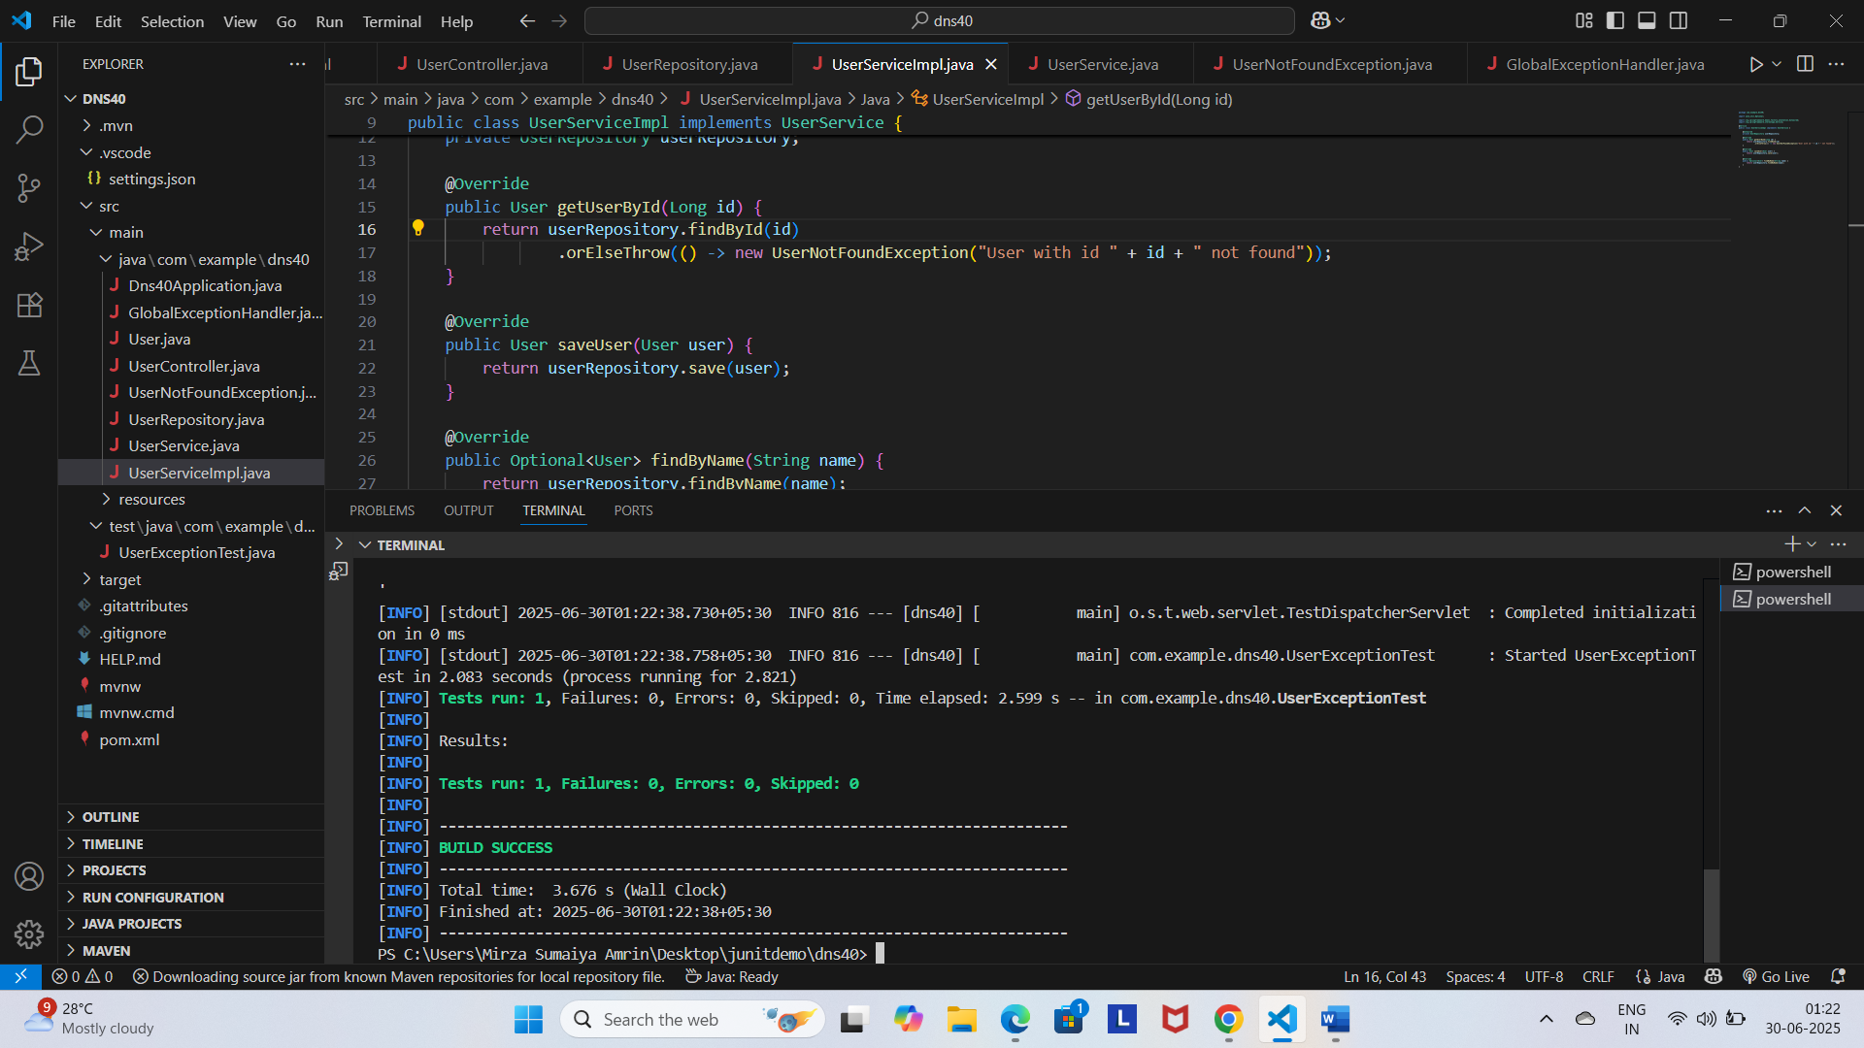**Output:**

**5.**

**Exercise 1**

**UserControllerTest.java**

package com.example.dns40;

import org.junit.jupiter.api.Test;

import static org.mockito.Mockito.when;

import org.springframework.beans.factory.annotation.Autowired;

import org.springframework.boot.test.autoconfigure.web.servlet.WebMvcTest;

import org.springframework.boot.test.mock.mockito.MockBean;

import org.springframework.http.MediaType;

import org.springframework.test.web.servlet.MockMvc;

import static org.springframework.test.web.servlet.request.MockMvcRequestBuilders.get;

import static org.springframework.test.web.servlet.result.MockMvcResultMatchers.jsonPath;

import static org.springframework.test.web.servlet.result.MockMvcResultMatchers.status;

@WebMvcTest(UserController.class)

public class UserControllerTest {

    @Autowired

    private MockMvc mockMvc;

    @MockBean

    private UserService userService;

    @Test

    void testGetUser() throws Exception {

        User mockUser = new User();

        mockUser.setId(1L);

        mockUser.setName("John Doe");

        when(userService.getUserById(1L)).thenReturn(mockUser);

        mockMvc.perform(get("/users/1")

                .accept(MediaType.APPLICATION_JSON))

                .andExpect(status().isOk())

                .andExpect(jsonPath("$.name").value("John Doe"));

    }

}

**Output:**

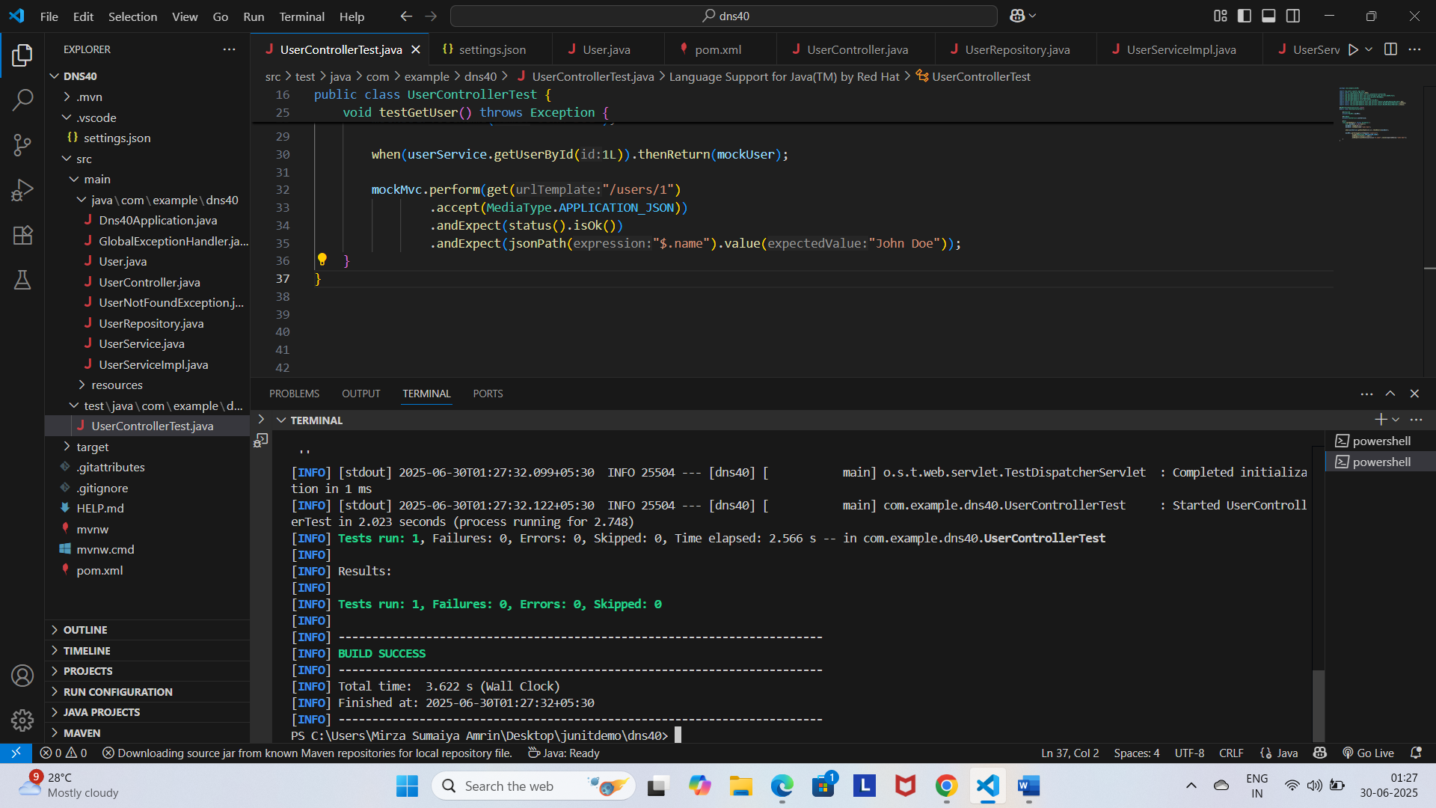

**Exercise 2**

**User.java**

package com.example.dns40;

import jakarta.persistence.Entity;

import jakarta.persistence.Id;

@Entity

public class User {

    @Id

    private Long id;

    private String name;

    public User() {}

    public User(Long id, String name) {

        this.id = id;

        this.name = name;

    }

    // Getters & Setters

    public Long getId() { return id; }

    public void setId(Long id) { this.id = id; }

    public String getName() { return name; }

    public void setName(String name) { this.name = name; }

}

**UserRepository.java**

package com.example.dns40;

import org.springframework.data.jpa.repository.JpaRepository;

public interface UserRepository extends JpaRepository<User, Long> {

}

**UserService.java**

package com.example.dns40;

import org.springframework.beans.factory.annotation.Autowired;

import org.springframework.stereotype.Service;

@Service

public class UserService {

    @Autowired

    private UserRepository userRepository;

    public User getUserById(Long id) {

        return userRepository.findById(id).orElse(null);

    }

    public void setUserRepository(UserRepository userRepository) {

    this.userRepository = userRepository;

}

}

**UserServiceTest.java**

package com.example.dns40;

import static org.junit.jupiter.api.Assertions.assertEquals;

import static org.junit.jupiter.api.Assertions.assertNull;

import static org.mockito.Mockito.*;

import java.util.Optional;

import org.junit.jupiter.api.Test;

public class UserServiceTest {

    @Test

    void testGetUserById_found() {

        UserRepository mockRepo = mock(UserRepository.class);

        UserService userService = new UserService();

        userService = spy(userService); // to inject mock

        User mockUser = new User(1L, "John Doe");

        when(mockRepo.findById(1L)).thenReturn(Optional.of(mockUser));

        // Inject mock manually

        userService = new UserService() {{

            setUserRepository(mockRepo);

        }};

        User result = userService.getUserById(1L);

        assertEquals("John Doe", result.getName());

    }

    @Test

    void testGetUserById_notFound() {

        UserRepository mockRepo = mock(UserRepository.class);

        when(mockRepo.findById(2L)).thenReturn(Optional.empty());

        UserService userService = new UserService() {{

            setUserRepository(mockRepo);

        }};

        User result = userService.getUserById(2L);

        assertNull(result);

    }

}

**Output:**

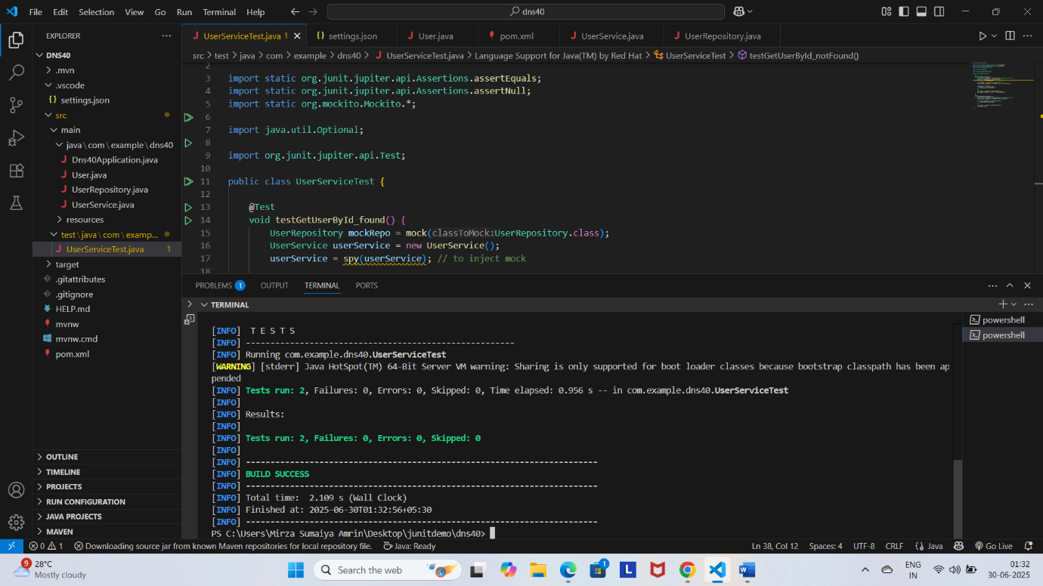

**Exercise 3**

**User.java**

package com.example.dns40;

import jakarta.persistence.Entity;

import jakarta.persistence.Id;

@Entity

public class User {

    @Id

    private Long id;

    private String name;

    public User() {}

    public User(Long id, String name) {

        this.id = id;

        this.name = name;

    }

    // Getters & Setters

    public Long getId() { return id; }

    public void setId(Long id) { this.id = id; }

    public String getName() { return name; }

    public void setName(String name) { this.name = name; }

}

**UserRepository.java**

package com.example.dns40;

import org.springframework.data.jpa.repository.JpaRepository;

public interface UserRepository extends JpaRepository<User, Long> {

}

**UserService.java**

package com.example.dns40;

import org.springframework.beans.factory.annotation.Autowired;

import org.springframework.stereotype.Service;

@Service

public class UserService {

    @Autowired

    private UserRepository userRepository;

    public User getUserById(Long id) {

        return userRepository.findById(id).orElse(null);

    }

}

**UserController.java**

package com.example.dns40;

import org.springframework.beans.factory.annotation.Autowired;

import org.springframework.http.ResponseEntity;

import org.springframework.web.bind.annotation.GetMapping;

import org.springframework.web.bind.annotation.PathVariable;

import org.springframework.web.bind.annotation.RequestMapping;

import org.springframework.web.bind.annotation.RestController;

@RestController

@RequestMapping("/users")

public class UserController {

    @Autowired

    private UserService userService;

    @GetMapping("/{id}")

    public ResponseEntity<User> getUser(@PathVariable Long id) {

        User user = userService.getUserById(id);

        return user != null ? ResponseEntity.ok(user) : ResponseEntity.notFound().build();

    }

}

**UserIntegrationTest.java**

package com.example.dns40;

import org.junit.jupiter.api.Test;

import static org.mockito.Mockito.when;

import org.springframework.beans.factory.annotation.Autowired;

import org.springframework.boot.test.autoconfigure.web.servlet.AutoConfigureMockMvc;

import org.springframework.boot.test.context.SpringBootTest;

import org.springframework.boot.test.mock.mockito.MockBean;

import org.springframework.http.MediaType;

import org.springframework.test.web.servlet.MockMvc;

import static org.springframework.test.web.servlet.request.MockMvcRequestBuilders.get;

import static org.springframework.test.web.servlet.result.MockMvcResultMatchers.jsonPath;

import static org.springframework.test.web.servlet.result.MockMvcResultMatchers.status;

@SpringBootTest

@AutoConfigureMockMvc

public class UserIntegrationTest {

    @Autowired

    private MockMvc mockMvc;

    @MockBean

    private UserService userService;

    @Test

    void testGetUserIntegration() throws Exception {

        User mockUser = new User(1L, "John Doe");

        when(userService.getUserById(1L)).thenReturn(mockUser);

        mockMvc.perform(get("/users/1")

                .accept(MediaType.APPLICATION_JSON))

                .andExpect(status().isOk())

                .andExpect(jsonPath("$.id").value(1L))

                .andExpect(jsonPath("$.name").value("John Doe"));

    }

}

**Output:**

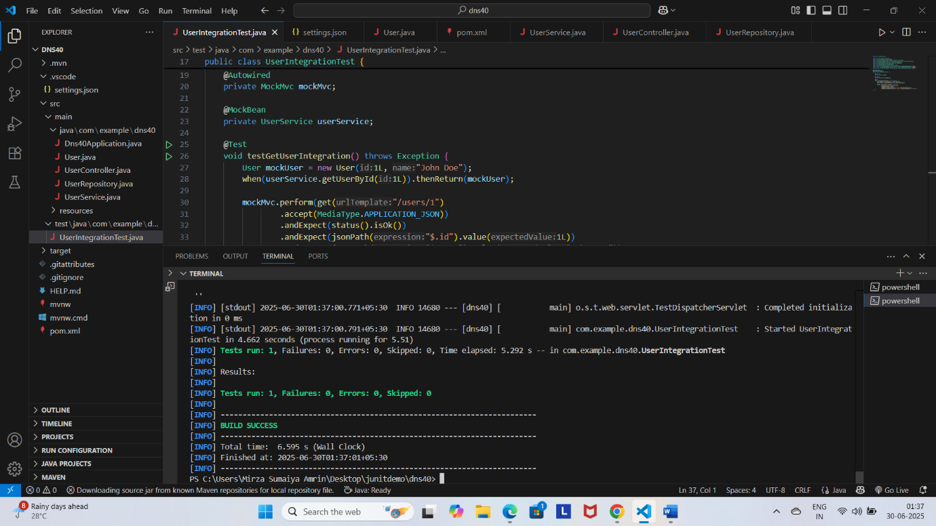

**6.**

**Exercise 1:**

**LoggingExample.java**

package com.example.dns40;

import org.slf4j.Logger;

import org.slf4j.LoggerFactory;

public class LoggingExample {

    private static final Logger logger = LoggerFactory.getLogger(LoggingExample.class);

    public static void main(String[] args) {

        logger.error("This is an error message");

        logger.warn("This is a warning message");

    }

}

**Output:**

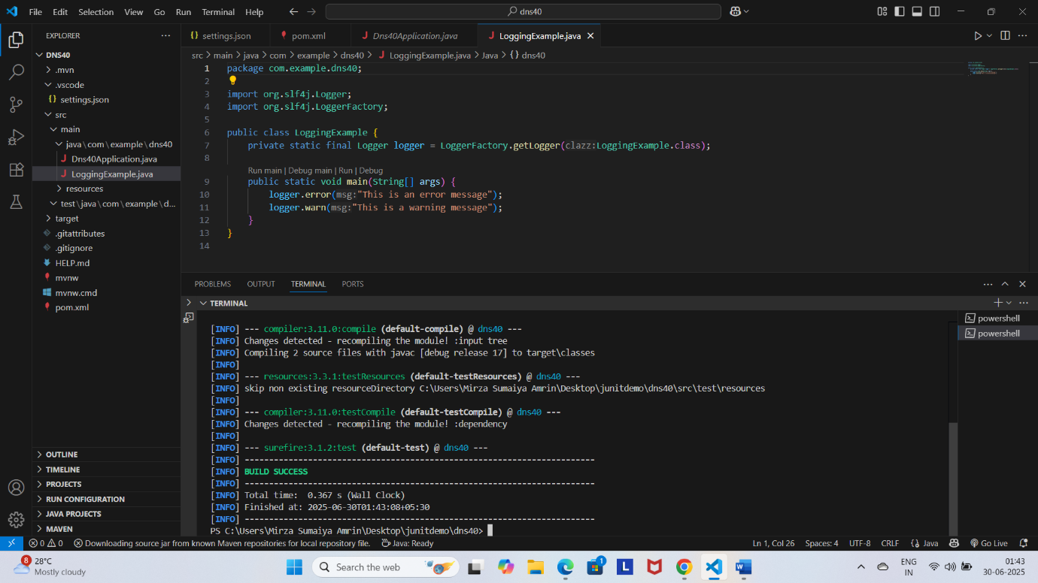

**Exercise 2:**

**ParameterizedLoggingExample.java**

package com.example.dns40;

import org.slf4j.Logger;

import org.slf4j.LoggerFactory;

public class ParameterizedLoggingExample {

    private static final Logger logger = LoggerFactory.getLogger(ParameterizedLoggingExample.class);

    public static void main(String[] args) {

        String username = "Sumaiya";

        int userId = 101;

        logger.info("User {} with ID {} has logged in.", username, userId);

        logger.warn("User {} attempted to access restricted area.", username);

        logger.error("Failed to load profile for user ID: {}", userId);

    }

}

**Output:**

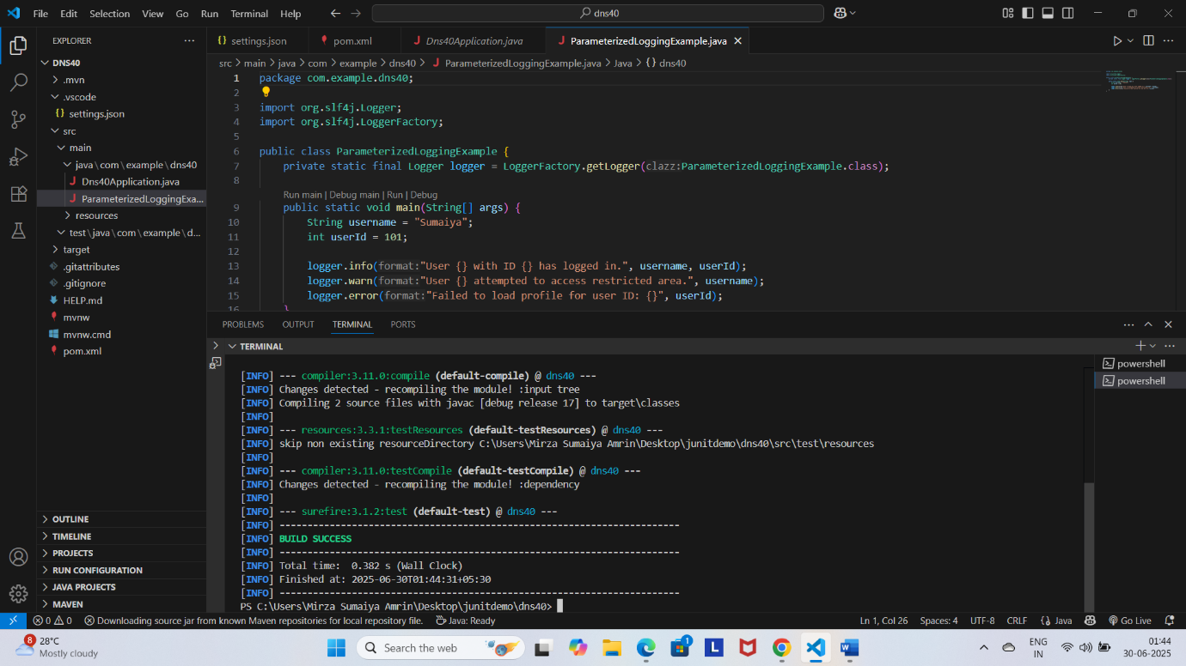

**Exercise 3:**

**AppenderExample.java**

package com.example.dns40;

import org.slf4j.Logger;

import org.slf4j.LoggerFactory;

public class AppenderExample {

    private static final Logger logger = LoggerFactory.getLogger(AppenderExample.class);

    public static void main(String[] args) {

        logger.info("Logging to both console and file.");

        logger.warn("This is a warning written to both destinations.");

        logger.error("This error will appear in console and app.log file.");

    }

}

**Logback.xml**

<configuration>

    <appender name="CONSOLE" class="ch.qos.logback.core.ConsoleAppender">

        <encoder>

            <pattern>%d{HH:mm:ss.SSS} [%thread] %-5level %logger{36} - %msg%n</pattern>

        </encoder>

    </appender>

    <appender name="FILE" class="ch.qos.logback.core.FileAppender">

        <file>logs/app.log</file>

        <append>true</append>

        <encoder>

            <pattern>%d{yyyy-MM-dd HH:mm:ss} [%thread] %-5level %logger{36} - %msg%n</pattern>

        </encoder>

    </appender>

    <root level="debug">

        <appender-ref ref="CONSOLE" />

        <appender-ref ref="FILE" />

    </root>

</configuration>

**Output:**

